SAMARTH SAMAJ’S
SHIVAJIRAO’S JHONDHLE
POLYTECHNIC AMBERNATH (EAST)

PROJECT REPORT ON

COLLEGE LIBRARY MANAGEMENT SYSTEM

YEAR: 2009-2010

Project Guided By: - Prepared By:-
1. PRIYANKA V. PAWAR.
2. HARSHALA K.GAIKWAD.
BEENA SENJALIYA 3.PRIYANKA N. KADAM.
4. SHRADDHA R. BHORE.

SAMARTH SAMAJ’S
SHIVAJIRAO S. JONDHLE POLYTECHNIC
AMBERNATH (E)

SUBMISSION

We, the undersigned student of Third Year INFORMATION TECHNOLOGY humbly submit that we have completed from time to time the project work as described in this report by our own skills and study between the period from ‘December 2009 to April 2010’ as per the instructions/guidance of “BEENA SENJALIYA”.

And that the following students were associated with me for this work.
However quantum of our contribution has been approved by the teacher.

1. PRIYANKA V. PAWAR.
2. HARSHALA K.GAIKWAD.
3. PRIYANKA N. KADAM.
4. SHRADDHA R. BHORE.

And that we have not copied the report or it’s any appreciable part from any other literature in contravention of the academic ethics.

Date: - Signature of Members:-

SAMARTH SAMAJ’S

SHIVAJIRAO S.JHONDHLE PLOYTECHNIC
AMBERNATH(EAST)

DEPARTMENT CERTIFICATE

Certified that the report Submitted by

MISS/KUM :-

SEAT NO.:- ROLL NO:-

A Student of third year of course “INFORMATION TECHNOLOGY” as a part of Project works as prescribed by the Board of Technical Examinations, Mumbai on

“COLLEGE LIBRARY MANAGEMENT SYSTEM”

For the EDP (Entrepreneurship Development and Project).
And that I have guided her/him for the said work from time to time and I have found her/him to be Satisfactory progressive.
And the following student was associated with her for this work.
However his/her contribution was proportionate.
1. PRIYANKA V. PAWAR.
2. HARSHALA K.GAIKWAD.
3. PRIYANKA N. KADAM.
4. SHRADDHA R. BHORE.
And that I have assessed the said work and I am satisfied that the same is up to the standard envisaged for the level of course.
And that said work may be presented to the external examiner.

Signature Signature Signature Signature
Name of External Head of dept Principle
The teacher examiner
Date: Date: Date: Date:

ACKNOWLEDGEMENT

We are very delighted to take the opportunity of introducing our project entitled.

“COLLEGE LIBRARY MANAGEMENT SYSTEM”
We would like to take opportunity to acknowledgement the innumerable guidance and support extended to us by our guide, “Beena Senjaliya” in execution and preparation of project & also we are very much thankful to head of department “Mrs. Archana Dhage”.
For their kind and timely help offered to us in prosecution of our studies and execution of this project in every stage.
Thanks to Mrs. Archna Dhage.
For their kind support for preparation of our project.

BY:-
PRIYANK V. PAWAR. HARSHALA K. GAIKWAD
PRIYANKA N.KADAM.
SHRADDHA R. BHORE.

Over the last few years, Computer already had a considerable impact on many aspects of our society, Medicine, Government, Banking, Education Institution, Engineering, Railway and Airline Reservations – these are only some of the fields in which computers are already playing an highly significance role. Over the next few years, there would be a great increase n the application of computer and would also have a wide use of computers in our day to day life.
In the year ahead, the database system will become increasingly widespread and increasingly importance. The number of systems installed or under development is growing at a considerable speed.
Our project is highly dedicated to high level languages. Our project reports covers wide spectrum of field & it is completely reference in itself only.
Aim of our project is not only to get information but to store all our information in a specific format so that we can easily retrieve it.
We have tried to our best to make this project best, but there may be possibility of coming error then also we hope that you will not find any difficulty in operating it.
Though we tried to give more and more easy and flexible to use. It is totally GUI based. According to us we considered & studied every side of coins, for those who know “VB 6.0”.
So our project whose depth can be measured with help of knowledge instrument, dedicated to our parents, madam who inspired us to reach this mark.
THANKING YOU.

- Recognition of need
- Feasibility Study
- System Analysis
- System design
- Testing and System implementation
- Post implementation & Maintenance
- System Documentation
- System Requirements
- Annexure
10. Bibliography

1. Recognition of need
  - Introduction
One must know what the problem is before it is solved. This basis for a candidate system is recognition of need for improving an information system or a procedure. Everyone has a survey or an initial investigation to determine whether an alternative system can solve the problem or not.
Software development is the process consisting of two major steps of system analysis and design. We have choice of three distinct approaches:
- SDLC method
- Structured analysis development method
- System prototype method
However, we have used the SDLC method for our project. The SDLC consist of following activities six activities:
- Determine the problem with the existing system and define it. This step also includes the changes in the inputs if any and objectives of the new system. It includes the following details
- Why is the existing system not satisfactory?
- Have the inputs changed, lost or are not available?
- What is the objective of the system analysis effort?

- This phase is related with the need of the new system. For this reason an initial investigation is made for the new system. Depending on the results of the initial investigation, the survey is expanded to a more detailed study.

It includes the following details
  - What are the user’s demonstrable needs and how does a candidate system meet them?
  - What resources are available for the given candidate system? Is the problem worth solving?
  - What are the likely impacts of the candidate system on the organization?
- In this step, the detailed study of the various operations performed by a system and the relationship of the components within and outside the system is determined. This phase includes the detailed study of the new system. Here we also need to determine whether or not a candidate system should consider other related system
Here the only key question is:
  - Are there any choices to improve or modify the system? If yes then what are the choices to improve the system?
  - What must be done to solve the problem?
- This step does not include much of the creative part. Here the user is trained to use the application. Also, site preparation and file conversion is carried out in this phase.
- This phase is done after the entire project is done. When the project is completed , an implementation is done in order to periodically maintain the hardware as well as software.
Because of these important characteristic of SDLC we implemented its policy.

1.2 Need for computerization

The general mentality of the computer user is to get the most powerful packages that are time saving as well as to produce good quality of reports.

This project can be used and operated by even a person not from the technical field. The need for computerization is strongly felt in area of keeping the records of books of particular Category. This is currently done manually and is extremely tedious and time consuming tasks.

The need for computerization also demands Member management facility. This is because a lot of paper work currently required. Also the staff management.

The facility of this report provides the answers for queries which would require tedious sorting and time consuming. Thus the need for computerization is duly satisfied along with the added asset of computers i.e. better output and readable reports.

Our project “College Library Management System” uses for marinating all books and members record to avoid the tedious paper working job. Because of the whole work is handling by this software then the chance of error proof data or time delaying in the reports ill reduce to a maximum extend.

  - Selection of language

It becomes necessary to select the language before the actual programming is done. Therefore selection of language should be such that the programmer could easily his/her thoughts into. He/She should have a deep knowledge about the language that she had decided to use. We have selected VISUAL BASIC 6.0 for our project.
Following are reasons for our selection of the language:-
- VB is a structured programming language
- It is an efficient interactive environment for designing forms and windows
- In VB you can quickly design the visual elements of any new programming project
- It is an Integrated Development Environment in which you can develop, run, test and debug your application.
Some features of Visual Basic 6.0 are as follows:
- Full set of controls
- It is based on basic language
- Lot’s of icons and pictures
- Response to mouse and keyboard actions
- Sequential and random access file support
- Active X support
- Clipboard and printer access
- Fast compiler
- Addition internet capabilities
- New data report designer

And we are using MS-Access because it provides facility of maintenance & storing data very easily. Here MS-Access acts as backend for VB6 front-end.

2. FEASIBILITY STUDY

2.1 Introduction

Feasibility study is conducted after the need is recognized in feasibility study analysis has to do evaluation of existing system & procedures. Depending on the results of initial investigations, the survey is expanded to a more details feasibility study. A feasibility study is a test of a system proposal according to its workability impact on the organization, ability to meet user needs, and effective use of resources .It focuses on three major questions.

- What are the user’s demonstrable needs and how does a candidate system meet them?
- What resources are available for given candidate system? Is the problem worth solving?
- What are the likely impacts of the candidate system on the organization?
The main objective of feasibility study is to acquire the sense of its scope.

2.2 Feasibility Considerations

There are three key considerations involved in the feasibility study viz.

2.2.1 Economical feasibility

Cost of the project can be estimated during feasibility study. Economical feasibility is one of the important factors, which evaluates the effectiveness of project. It also referred to s cost/benefit analysis. If system would be too costly, would not be accepted user economical feasibility, whether there are benefits in creating the system to make the cost acceptable.
It is very important to estimate the cost of the system before the development of the system. The cost must be estimated accurately because it must match with the final cost of the system. While calculating the cost, we should consider like cost for furniture, hardware, software maintenance and supplies.
For the same reason we estimated the software, hardware as well as the furniture cost of our project. If the cost of the input increases the limit then the project does not serve any purpose. So while estimating the cost the input cost should always be worth for the output.

- Tangible benefits
While developing any application the cost factor is an important thing to be considered. The cost of the software should deserve as per advantages it provides. This is tangible benefit. However it also includes the purchase of hardware and software, personal training and employee salaries.

- Intangible benefits
Intangible benefits are more valuable and more reliable as compared to the tangible benefits. It refers to the maintenance of the intangible benefits
- Better record management.
- Easy accessibility.
- Avoidance of respective work.
2.2.2 Technical feasibility

Technical feasibility includes whether the proper technology is available of designing the system & it can support the proposal addition. It centers on the existing computer system.
Technology tools provide detailed solution to help manage businesses in an efficient & cost-effective manner. So the technology used in the designing of the system should be used in the proper manner.
Hardware Requirement:
- CPU-Pentium IV,2.4 GHZ
- RAM-DDR 256 MB
- Monitor-Color with high resolution
- Hard disk-20 GB
- Floppy disk-1.44 MB FDD
Software Requirement:
- Windows 2000
- Microsoft Visual Studio
- MS-Office 2000
Technical feasibility centers on the existing computer system including the hardware software etc and what extent it can support the proposed change. This involves financial consideration to accommodate technical enhancements. If the budget is a serious constraint, then the project is judged not feasible. In our project our main aim was to make sure the working of the software should be technically correct. We also assured that the steps are followed as prescribed while designing the project and the user is satisfied with the content we have provided.

2.2.3 Behavioral feasibility
Almost each one of us is interested in consuming fewer efforts and less time in consumption of job keeping this fact in mind. We have made earnest efforts to this requirement. No special training is required to deal with our software, thus saving the cost of training. Any person who is aware of VB 6.0 can easily operate our system. So we claim that our system is user friendly. There are certain steps involved in feasibility analysis, which were very important in the development of our project.

The steps are as follows:
- Forming a project team
- Preparing system flowchart
- Enumerating potential candidate
- Describing and identifying characteristics of candidate system
- Determining and evaluating performance and cost effectiveness of each candidate system
- Determining system performance and data
- Preparing and reporting final project directive to our project guide.

People are inherently resistant to change and computers have been known to facilitate change. An estimate should be made how strong reaction the user staff is likely to have towards the development of computerized system. It is a common knowledge that computer installations have transfers, retraining and changes in employee job status. While working on the currently available (that is pen or paper) application it takes a lot amount of time.
2.3 Determination of feasibility
The outcome of the initial investigation is, it determines whether alternative system is feasible. A report summarizing the thinking of the analysis is presented to the user of overview. At this time, it is the important to identify the principle user.
After organizing and summarizing, the analyst has a thorough knowledge of the system. The following information should be available
- Interview and correspondence records
- Update system documentation
- Flowchart
- Familiarity with names, positions and personalities of user personal
- Specification of good and bad features of the current system
- Understanding of how well is the actual problem facing the system, are in line with the problems stated in users request form.
The outcome of the initial investigation is it determines whether alternative system is feasible. A report summarizing the thinking of the analyst presented to the user of overview .At this time it is important to identify the principle user. The final decision is the end users response to a project directive. When approve, it becomes an automation document that also reflects the results of the decision made during the final review. More &more organization has computer user committee, as a final approval authority for a project undertaken.
2.4 Feasibility Report
The communication of the feasibility study is the feasibility directed to the management. It evaluates the impact of proposal changes on the area in questions. The report is the formal document to be understandable, yet to be detailed enough to provide the basis for system design.
There is no standard format for preparing feasibility report. Analyst usually decides on a format that suits the particular user and system. Most report however is being with the summary of finding and recommending the documented detail starting with summary information highlights essence of the report giving the management option of reviewing the details later.
THE REPORT CONTAINS FOLLOWING CONTENTS:
- Cover letters formally present the report and briefly indicate the nature to the management.
- Table of contents specifies the location of various parts of the report; management quickly refers to the section that concern them
- Overview is narrative explanation of the purpose and scope of the project, the reason for undertaking the feasibility study and the department involved and thereby effected candidate system.
- Finding the detailed outline method to be used in present system. The system effectiveness and efficiency as well as the operating cost are emphasized. This section also provides the description of objectives and general procedure of candidate system. A discuss of the output report cost and benefits give the management a fee for the pros and cons of the candidate system
- Economics justification details point cost comparison and preliminary development of the candidate
- Recommendation and conclusion suggest to the management. The most beneficial and cost effective system. They are not only written as recommendation but also as command. Following the recommendation any conclusion from the study can be included
- During the investigation, all memos and data are complied. They are placed at the end of the report for reference.

2.5 Cost Estimation

Cost estimation is a total expenditure of the project requirements. All the materials required for the project along with their approximate prices are listed below:

- Hardware cost
It is related to the actual purchase or lease of the computer and its peripherals. For example: printer, disk drive, tape unit.
- Personal cost
It includes staff salary and benefits that is health insurance, vacation time, sick pay etc. It also includes the pay for those who are involved in developing the system
- Facility cost
It includes writing, flooring acoustics, lighting and air conditioning. These cost are treated as one time cost and are incorporated to the overall cost estimate of the candidate system
- Operating cost
It includes all costs associated with the day to day operation of the system; the amount depends on the number of shifts, the nature of application and the caliber of operating staff.
- Supply cost
This is a variable cost that increases with an increased use of paper ribbon and disks. They should be estimated and included in the overall cost of the system.

3. SYSTEM ANALYSIS
3.1 Introduction
During analysis the data ate collected from the available files, decisions points and transaction handles by the present system. Interview, onsite observation and questionnaires are examples of tools and system models that are used in analysis. It requires special skills interviewed ideas in data collection and interpretation can be a problem training experience and common sense are required for collection of the information needed to do analysis.
Analysis is a detailed study of the various operation performed by the system and their relationship with outside of the system. One aspect of the analysis is defining the boundaries of the system and determining whether or not a candidate system should consider other related system.
During analysis it becomes necessary to study the different operations performed by the systems, the way to collect the data and the different options on which the work has to be done. A system should be designed by its boundaries. The limits identify its components, process and interrelationships when it interfaces with other systems. Each system has boundaries that determine its sphere of influence and control.

3.2 Information Gathering
A key part of the analysis is gathering information about the present system. The analyst must know what information to gather, where to find it, and what to make of it. The proper use of tools for gathering information is the key to successful analysis. Data can be collected through interviews, questionnaires, group discussions and also by examining the system. The traditional approach is to organize and convert the data through the tool for structure analysis such as flow charts, data flow charts and data flow diagrams.

Information gathering is an art and science. Information gathering implies meeting people to know their views browsing through the internet, visiting different sites and collecting information related to the project.

Information Gathering does not mean only collection of information but it also includes the security of the information gathered. The person gathering the information should have the knowledge of:
- When to gather the information
- From where to gather the information
- What changes should be made in securing information

The approach and manner in which information is gathered required person with sensitivity, common sense and knowledge of what and when to gather and what changes to use in securing information.

3.3 Interviews
Information gathering deals with the most important term called “ Interview”. When it comes to information gathering .It becomes necessary to carry out interviews. For our COLLEGE LIBRARY MANAGEMENT SYSTEM. we needed to interview different people dealing with the cyber café.
The benefits we derived from the interviews are as follows
- It made our project flexible by enhancing superior technique
- It offered an opportunity to make our system reliable
- It provided us with an idea of a different techniques which was already present in an existing system to be accompanied with a new system in a different manner
- It made our project reliable, interesting and thereby complex.
3.4Observation:-
Through out the all system analysis process we can manage all data or information uses the proper analysis technique.
First we can understand all customer requirements. Then take glance of previous system and belong with this two condition we can develop rough paper work. And then develop system using VB6.0 IDE.
We can manage databases regarding to which fields we won’t to save or retrieve. Using Database and IDE form we develop “College Library Management System.”
3.5 Resources
Resources implies the equipments used in the project or simply the software requirement of the project. The hardware resources used for our project are the furniture, chair; table most importantly a personal computer along with the CPU, Keyboard, mouse and a color printer. The software resource includes Ms Office, Microsoft visual basic 6.0 and Ms Access.

3.6 Analysis of Current System
As we know Library is way to provide a various books for reading purpose. The Books are in various categories. In present system all books are manage with there authors, categories, ISBN codes.
All this records are kept in register. Manually librarian keep all books record. Not only kept books record but also keep all library member records.
Member records are related with their name, contact information, issue books, return books and fine record. All this records are store manually by librarian.
Every month librarian calculates net balance of library. Librarian collect monthly fee and membership deposit for all members. Based on this library invest collected money in books purchasing.
Librarian also make reports on all this task manually which is much time consuming and tedious job
3.7 Analysis of System Requirements

Determination of system requirements involved studying the current to find out how it worked and where improvements are to be made. This study of the existing system helped us in an evaluation of how the current methods were working or whether modification is to be done.

Requirement is a feature, which are included in our software development system. It included a way of capturing or processing the data, producing information, controlling a business activity or supporting management. Development answers to a specific group of questions always helped us to understand the basic requirement. Requirement investigation is an activity in which we used a variety of tools and skills to study the current system and document it features for further analysis. it relived a fact finding techniques and including methods for documenting and describing system features.

3.8 Structured Analysis
Traditional approach of analyzing the system is to organize and convert the data into system flowcharts. Flowchart is the oldest graphic tool. It is used to represent the flow of system. a flowchart consist of series of symbols and connections among them. System flowcharts are difficult to maintain or modify. Nowadays there are many books available for analysis and design such as context diagram. DFD’s etc.
Structured analysis is a set of technique and graphic tools that allow developing a new kind of system specifications that allow the analyst to develop a new kind of system specifications that are easily understandable to the user.
Attributes of structured analysis
- It is a graphical representation of the system
- It is the representation of areas of system rather than the physical one
- More stress is given on representation of area, which are more interest to users.

Limitations of Project
- This system is not base on client-server application so only one user can use this system.
- This system is use all Library‘s because the process is similar at least some extends.

4. SYSTEM DESIGN
4.1Introduction
The most creative and challenging phases of the system life cycle is System Design. The term design describes a final process by which it is developed. It refers to the technical specifications like what will be applied in implementing the candidate system. It also includes construction of program and program testing.
The term design describes a final system and the process by which it is developed; it refers to the technical specification that will be applied in implementing the candidate system, this includes construction of program. Thus, the designing part is depending on data from analysis phase. Therefore the output of analysis acts as an input to the design.
4.2 Design Methodologies that attempts to do the following:
- Improve productivity of analyst and programmer
- Improve Documentation & subsequent maintenance and enhancement
- Cut down drastically on cost-overruns & delays
- Improve Communication among the User, Analyst, Designer & Programmer
- Standardize the approach to analysis &design
- Simplify design by segmentation

4.3 Logical Design

Here we are describing overview of College Library Management System.
The College Library Management System is designed & developed for a receipt and issuance of books in the library along with the member’s details. The books received in the library are entered in Books Entry form and the new member is entered in the member entry form. When the member wants to get the desired book the same is issued on the availability basis to the member.
The issuance and due date for the returning of the book is also entered into the Book Issue form under third menu Book Issue. The member has to pay the fine if any on the basis of no. of days delayed deposit of the book in the library.
Our system keep records of all members which are store in particular database.
These stored records are use for many other functions.
Following are detail about our Computerize system which name is

“College Library Management System”

Member
Administrator
Employee

COLLEGE
LIBRARY
MANAGEMENT
SYSTEM
Get Memid
Register
Set Settings

Maintain record
Generate Reports

Return book

Issue book
Donner
Fund
Give Receipts
Database
CLMS
Data Transferring

5. SYTEM IMPLEMENTATION
  - Introduction

The implementation phase is less creative than system design. It is primarily concerned with Site preparation, File conversion and User Training. When the candidate system is linked to terminals or remote sites, the telecommunication net work and the tests of the network along with the system are also included under implementation. The basic purpose of the development of our project is to implement it. It is only on implementation that we would come to know the success related to the project.
After the design of the system is finished the next phase is system implementation. The implementation phase is less creative than system design. It is primarily concerned with user training, site preparation and file conversion. During the final testing user acceptance is tested, followed by the user training depending on the nature of the system, extensive user training may be required . Conversion usually takes place at about the same time the user is being trained or later.
The crucial face in the system lifecycle is the successful implementation of the new system design. Implementation simply means making a system design completely operational and working. System implementation of three main tasks namely,
- Program the new system , test the program and then implement the new system.
- Analysis and design phases are concerned with the analyzing and designing a proposed system
- Implementing phase is concerned with building the new system.
In the extreme , the programmer is falsely viewed as someone who out to be isolated from other aspects of system development. Programming is itself design work, however the initial parameter of the candidates system should be modified as a result of programming efforts. Programming provides a reality test for the assumption made by the analyst. It is therefore a mistake to exclude programmers from the initial system design.
The entire team member such as the project manager, analyst and programmer are responsible to carry out the implementation of the system.
  - System Testing

The final stage in the development of a software package includes testing. Testing includes verification of the basic logic of each program and verification that the entire system works properly. As we know that any errors have gone undetected during system design multiply during code construction, we need to thoroughly test the programs so that they are entirely error free. The number and nature of errors in new design depend on several factors viz.
- The programmers ability to generate a code that exactly reflects the system design
- The time frame from the design
- Communication between the programmer and system designer
Testing of the system also includes verification of basic logic of each program and verification that the entire system works properly. As we know that no program or system design is perfect, communication between the user and the designer is not always complete or clear and time is usually short. Therefore testing of the system becomes vitally important.
Activities involves in the system testing are as follows:
- Prepare test plan
- Specify conditions for user acceptance testing
- Prepare test data for program testing
- Prepare test data for transaction path testing
- Plan user training
- Compile/assemble program
- Prepare installation documents
- Prepare operational documents

  - User Training
User training is nothing but getting the user familiar with the system which gives clear idea about the software. Sometimes it may happen that we develop some software, but after developing we come to know that the software is not user friendly i.e. the user working with the system is not familiar with it. It creates problems with the user who works with the software. This causes the failure of the software. In this case, the user needs training program to learn to use the software.
An analysis for user training focuses on two factors viz. User Capabilities and Natures of the System being installed. Training has to be given to the specific User based on his/her capabilities and the system complexity. Thus the training levels and duration for each User are determined.
User involvement and training takes place parallel with programming for basically three reasons:
- The system group has time available to spend on training while programs are being written
- Initiating the user training programs gives system group a clearer image of user’s interest in new system
- A trained user participates more effectively system training
Software developed for large applications are a bit complicated. They therefore require a trained user so that ,software becomes user friendly. The user should be therefore properly trained before he accepts such software or else it may cause the software to fail.

5.4 Motivation
It is an important tool of implementation. Motivation is necessary for implementation because the user may reject the design that may lead to the failure of the project . The Users must be well advised and they should be involved right from the Design phase so as to enable positive participation in the project execution.

5.5 Maintenance
Maintenance is an enigma of any system development. Maintenance is also required to remove the aging effect. The system must not be bulky and generally should be universal in nature. Analyst and programmers spend more time and money maintaining the program rather than developing it. Our project can run easily on the computer system that is most comfortable to use and does not require to much of maintenance.
Maintenance is the part of SDLC which involves the following tasks:
- Correcting errors
- Resolving necessary changes
- Enhance or modifies the system
- Assigns staff to perform maintenance activity
- Provides for scheduled maintenance

6. POST IMPLEMENTATION & MAINTAINCE
6.1 Introduction
Evaluations of a new system after it has been in operation to determine its actual performance against expectations are called post implementation activities. It involves further modifications for advance use and seeking improvements. After User starts working regularly with the new system, the system becomes functional. But it may need maintenance and enhancements in future. As everybody knows, any system in the world is not perfect. It may also happen that the User is not satisfied with the existing system. Hence, the system may require periodic information. This will help in increasing the performance of the system.
Operational systems are quickly taken for granted. Every system requires periodic evaluation implementation review the measures of the system’s performance against predefined requirement, unlike system’s testing, which determined whether the system fails so that the necessary adjustment can be made, a post implementation reviews continuously to meet the specifications.
Post Implementation activity take place after about a year to determine that whether the system is perfectly working or not, whether the system is satisfying the user needs or not, if not changes are made to the system to make it perfect.

6.2 Future Development
The New System Profile:-
The proposed system uses advanced technologies. The application is designed to fit the present requirement of College Library Management System. It uses interactive yet powerful applications as Visual Basic and MSAccess.This system has a high security level. It checks the login for different users and gives rights to them according to their designations. This system automatically registers an Administrator for the full functionality of the application.

The following points shows us Advantages of our system:-
    - All the records of members are checked in easy way.
    - Using system, we can find particular records of member instant of time.
    - Operator has to put just Member ID of member, and then all information will display on the screen.
    - It directly increments member id so it is very easy to fill the details of member.
    - We can easily enter book record and safely and easily made issue/return transaction.
    - We can also provide facility to set administrator setting no one can change Administrator setting without administrator login.
    - If incorrect account number is entered then, this system shows error or message box.
    - This system is giving the output in the form of reports both hard and soft copies.

6.3 Conclusion
Thus, we concluded our text about the software project. By developing such a software project we experienced a fair knowledge of accomplishment of system. At the same time this software has helped to understand the depth of Visual Basic 6.0 as we have use a lot of commands for our project development.
As the software created by us is user friendly package which will make the user easy to work on. We had a number of ups and downs in the designing of our project but we finally became successful to achieve our task. This software is a milestone in our carrier.

6.4 Further Post Implementation
Though our project is big enough to provide information, because of time factor we were unable to mould it according to our ideas. However, we would surely make it a point to complete our project in future. We will include all the possible potions to make it more effective and information. This will enhance our project in terms of contents.

6.4 Maintenance

Though the system is efficient to work it requires regular maintenance.

7. System Documentation
7.1 Entity Relationship diagram

Administrator
Fee
Member

Book

Issue
Employee

Donor
Fine

7.2 Data Flow Diagram
7.2.1 Context Level Diagram

0
College Library Management System
Member
Member Details
Issue/Return Details
Book Details
Doner Details
Fee Details
Get Book
Return Book
Fee
Fee receipts
Get Member Id.
Fill Details
Check Details
Give Details
Check Conditions
Return Fine
Check & Store
Check & Store
Check & Store
Withdraw Money
Employees Details
Get Password & User id
Check & Store

7.2.2 Top Level Diagram

0.1
Member Details
0.2
Book Details
0.3
Issue
Return
0.4
Fee
Details

0.5
Global
Information
Member
Member Details
Enter Book Details
Return Book
Give deposit money
Return Fee receipt
Member
Book
Issue
Fee
Fee
Member Details
Member Details
Member ID
Issue
Doner
Admin/Employee
Employee

SYSTEM REQUIREMENTS

Details of software used:-

The anticipated system has been totally developed in two environments with front-end as ‘Visual Basic 6.0’ and back-end as ‘Microsoft Access 2000’.

Hardware Specifications:
- 256 MB HDD
- 256 MB RAM
- Dot Matrix Printer, Laser Printer, etc.

9.Annexure
9.1 Forms
Login Form
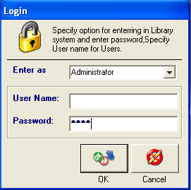
MDI Form
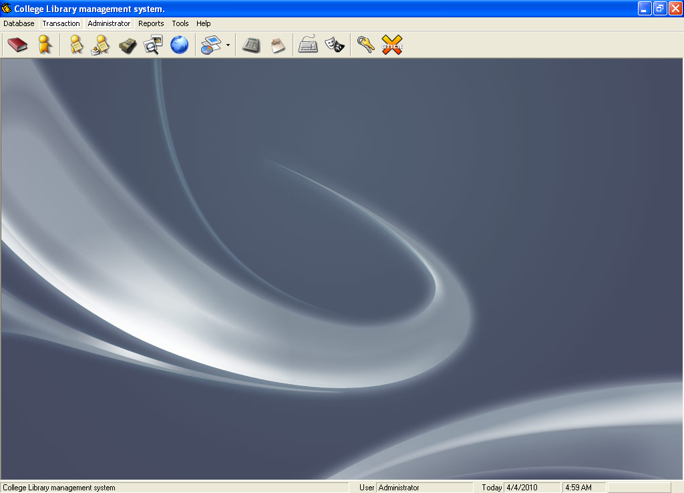
Book Detail Interface
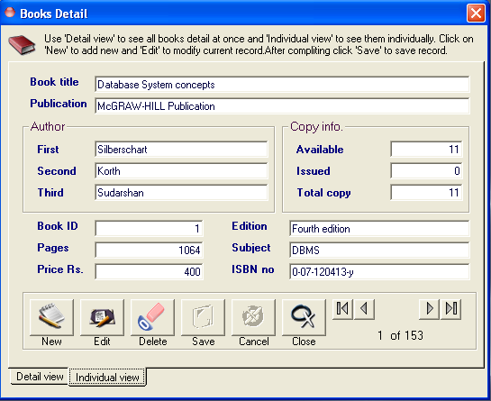

Student Detail Interface
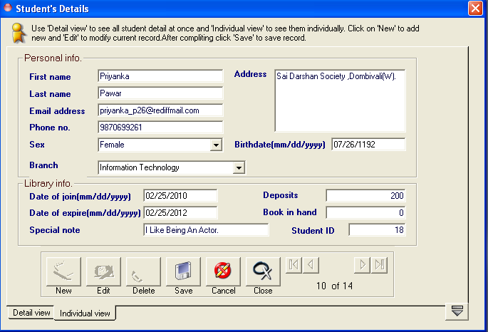

Donation Entry

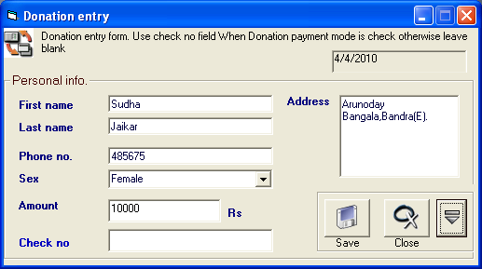

Issue Interface

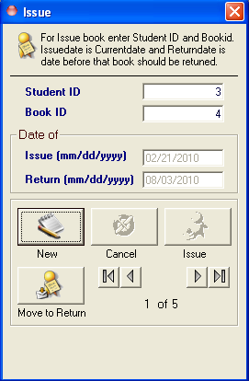
Return Information

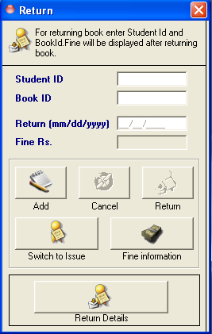

Fine Information
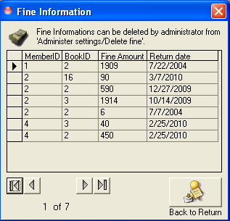

Student Monthly Fee Information

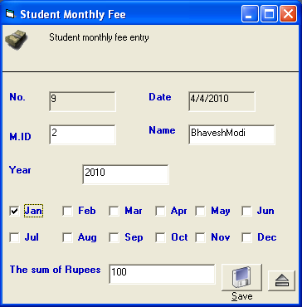

Search Information

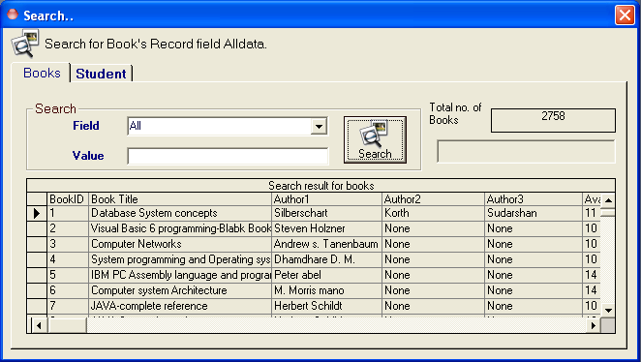
Global Information
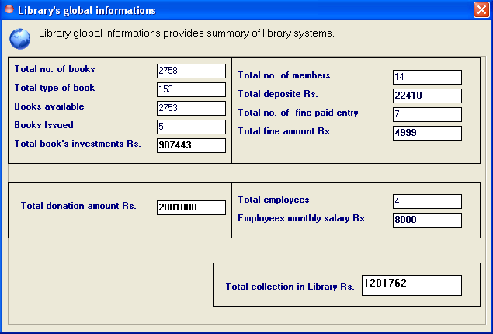

Employee’s Details
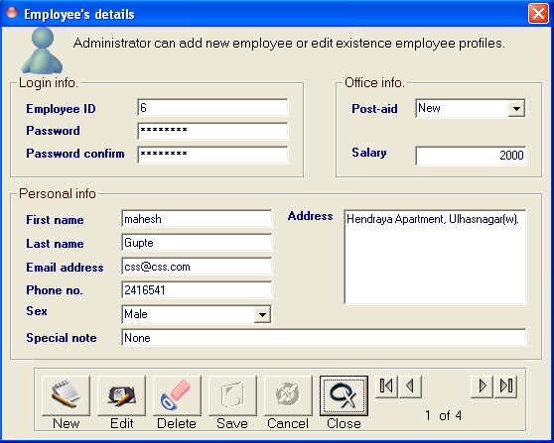

Backup Interface

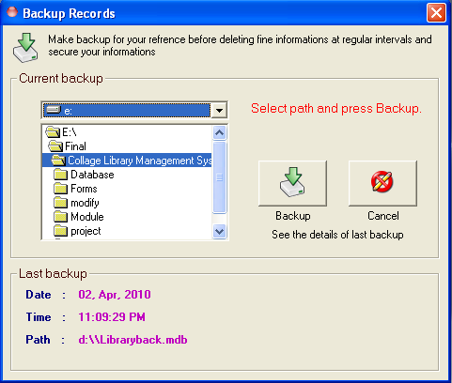

Administrator Setting
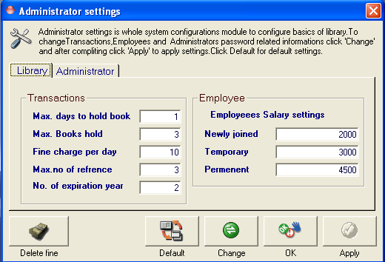
Book Report Interface

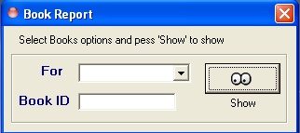

Student Report Interface

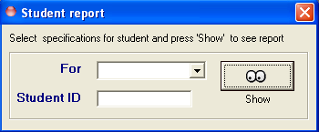

Student Issue- return Report

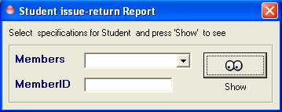

Book Report
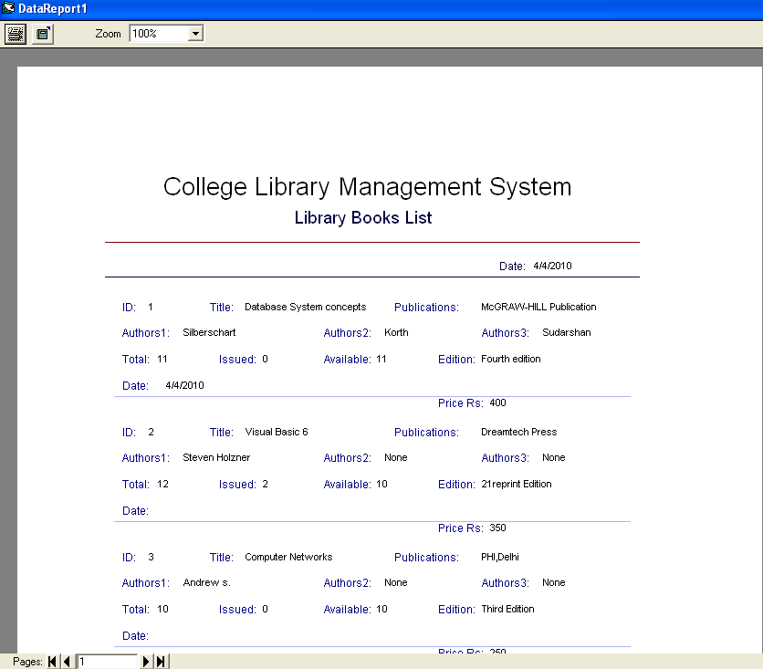

Member Report

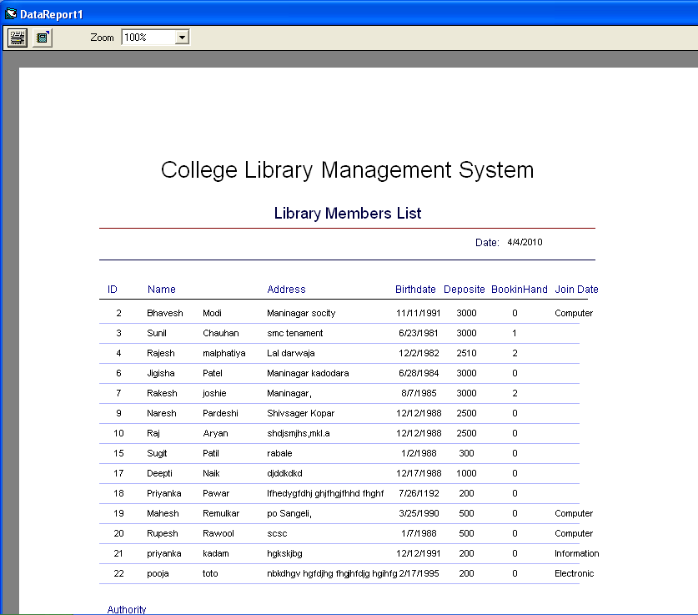

Issue – return Information

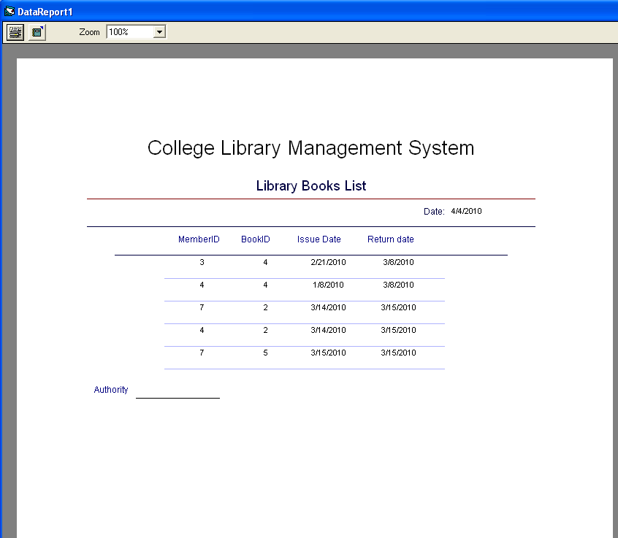

9.2 Source Code
MDI Form Coding

Private Declare Function OSWinHelp% Lib "User32" Alias "WinHelpA" (ByVal hWnd&, ByVal HelpFile$, ByVal wCommand%, dwData As Any)
Private Declare Function ShellExecute Lib "shell32.dll" Alias "ShellExecuteA" (ByVal hWnd As Long, ByVal lpOperation As String, ByVal lpFile As String, ByVal lpParameters As String, ByVal lpDirectory As String, ByVal nShowCmd As Long) As Long
Private Declare Sub Sleep Lib "kernel32" (ByVal dwMilliseconds As Long)
Private Sub MDIForm_Load()
Me.Show
Me.Enabled = False
'setting toolbar images
With Toolbar2
Set .ImageList = ImageList1
.Buttons(2).Image = 1
.Buttons(3).Image = 7
.Buttons(5).Image = 5
.Buttons(6).Image = 6
.Buttons(7).Image = 14
.Buttons(8).Image = 2
.Buttons(9).Image = 3
.Buttons(11).Image = 10
.Buttons(13).Image = 8
.Buttons(14).Image = 9
.Buttons(16).Image = 12
.Buttons(17).Image = 13
.Buttons(19).Image = 4
.Buttons(20).Image = 11
End With
sbStatusBar.Panels(3).Text = "Login"
End Sub
Private Sub MDIForm_Unload(Cancel As Integer)
On Error Resume Next
If MsgBox("Are You Sure you want to Quit ?", vbExclamation + vbOKCancel, "Library Management System") = vbOK Then
Unload frmLogin
Else
Cancel = True
End If
End Sub
Private Sub mnuCHR_Click()
Load Frm_return
Frm_return.Show
End Sub
Private Sub mnuDon_Click()
Load Frm_donation
Frm_donation.Show
End Sub
Private Sub mnuFee_Click()
Load Frm_fee
Frm_fee.Show
End Sub
Private Sub sm_about_Click()
Load frmAbout
frmAbout.Show
End Sub
Private Sub sm_backup_Click()
Load Frm_backup
Frm_backup.Show
End Sub
Private Sub sm_bookrpt_Click()
Load Frm_bookrpt
Frm_bookrpt.Show
End Sub
Private Sub sm_books_Click()
Load Frm_books
Frm_books.Show
End Sub
Private Sub sm_calculator_Click()
On Error GoTo errHandle
Dim a As Double
a = Shell("C:\WINDOWS\System32\calc.exe", vbNormalFocus)
Exit Sub
errHandle:
MsgBox "Unable to run Calculator Utility on your computer", vbInformation, "Error in opening!!!"
Resume Next
End Sub
Private Sub sm_employees_Click()
Load Frm_Employees
Frm_Employees.Show
End Sub
Private Sub sm_exit_Click()
Unload Me
End Sub
Private Sub sm_fine_Click()
Load Frm_Fine
Frm_Fine.Show
End Sub
Private Sub sm_global_Click()
Load Frm_global
Frm_global.Show
End Sub
Private Sub sm_help_Click()
Dim nRet As Integer
If Len(App.HelpFile) = 0 Then
MsgBox "Unable to display Help Contents. There is no Help associated with this project.", vbInformation, Me.Caption
Else
On Error Resume Next
nRet = OSWinHelp(Me.hWnd, App.HelpFile, 3, 0)
If Err Then
MsgBox Err.Description
End If
End If
End Sub
Private Sub sm_hsearch_Click()
Dim nRet As Integer
'if there is no helpfile for this project display a message to the user
'you can set the HelpFile for your application in the
'Project Properties dialog
If Len(App.HelpFile) = 0 Then
MsgBox "Unable to display Help Contents. There is no Help associated with this project.", vbInformation, Me.Caption
Else
On Error Resume Next
nRet = OSWinHelp(Me.hWnd, App.HelpFile, 261, 0)
If Err Then
MsgBox Err.Description
End If
End If
End Sub
Private Sub sm_issret_Click()
Load Frm_issretrpt
Frm_issretrpt.Show
End Sub
Private Sub sm_issue_Click()
Load Frm_issue
Frm_issue.Show
End Sub
Private Sub sm_logoff_Click()
If MsgBox("Are You Sure you want to logoff ?", vbExclamation + vbOKCancel, "Library Management System") = vbOK Then
Call logoff
DoEvents
End If
End Sub
Private Sub sm_member_Click()
Load Frm_memrpt
Frm_memrpt.Show
End Sub
Private Sub sm_members_Click()
Load Frm_members
Frm_members.Show
End Sub
Private Sub sm_notepad_Click()
On Error GoTo errcode
Dim a As Double
a = Shell("C:\WINDOWS\System32\notepad.exe", vbNormalFocus)
Exit Sub
errcode:
MsgBox "Unable to run Notepad Utility on your computer", vbInformation, "Error in opening!!!"
Resume Next
End Sub
Private Sub sm_return_Click()
Load Frm_return
Frm_return.Show
End Sub
Private Sub sm_search_Click()
Load Frm_search
Frm_search.Show
End Sub
Private Sub sm_settings_Click()
Load Frm_settings
Frm_settings.Show
End Sub
Private Sub smnu_keyboard_Click()
Load Frm_keyboard
Frm_keyboard.Show
End Sub
Private Sub Toolbar2_ButtonClick(ByVal button As MSComctlLib.button)
Select Case button.Index
Case 2: Call sm_books_Click
Case 3: Call sm_members_Click
Case 5: Call sm_issue_Click
Case 6: Call sm_return_Click
Case 7: Call sm_fine_Click
Case 8: Call sm_search_Click
Case 9: Call sm_global_Click
Case 11: 'add report
Case 13: Call sm_calculator_Click
Case 14: Call sm_notepad_Click
Case 16: Call smnu_keyboard_Click
Case 17: Call sm_about_Click
Case 19: Call sm_logoff_Click
Case 20: Call sm_exit_Click
End Select
End Sub
Private Sub Toolbar2_ButtonMenuClick(ByVal ButtonMenu As MSComctlLib.ButtonMenu)
Select Case ButtonMenu.Index
Case 1:
Call sm_bookrpt_Click
Case 2:
Call sm_member_Click
Case 3:
Call sm_issret_Click
End Select
End Sub

Book Details Form

Dim Bookrecord As ADODB.Recordset
Dim Bookconnection As ADODB.Connection
Dim str As String
Dim slct As String
Dim saveflag As Boolean
'Function cheaking validity of textbox
Private Function cheak() As Boolean
'declaring variable
Dim status As Boolean
status = False

If txt_title.Text = "" Then
MsgBox ("Please enter the Title."), vbInformation, "Information required"
ElseIf txt_publication.Text = "" Then
MsgBox ("Please enter the Publications."), vbInformation, "Information required"
ElseIf txt_author1.Text = "" Then
MsgBox ("Please enter the First Authors name."), vbInformation, "Information required"
ElseIf txt_Bookid.Text = "" Then
MsgBox ("Please enter bookid distinct from other"), vbInformation, "Information required"
ElseIf txt_pages.Text = "" Then
MsgBox ("Please enter no of pages of book."), vbInformation, "Information required"
ElseIf txt_price.Text = "" Then
MsgBox ("Please enter the price."), vbInformation, "Information required"
ElseIf txt_totalno.Text = "" Then
MsgBox ("Please enter no of copies."), vbInformation, "Information required"
ElseIf txt_issue.Text = "" Then
MsgBox ("Please enter no of copies issued."), vbInformation, "Information required"
ElseIf txt_avano.Text = "" Then
MsgBox ("Please enter no of copies available."), vbInformation, "Information required"
ElseIf txt_edition = "" Then
MsgBox ("Please enter the detail about edition of book."), vbInformation, "Information required"
ElseIf txt_subject.Text = "" Then
MsgBox ("Please enter subject related to the book."), vbInformation, "Information required"
ElseIf txt_isbn.Text = "" Then
MsgBox ("Please enter ISBN no. for book."), vbInformation, "Information required"
ElseIf IsNumeric(txt_author1.Text) Then
MsgBox ("Enter the valid author name."), vbInformation, "Invalid information"
ElseIf IsNumeric(txt_author2.Text) Then
MsgBox ("Enter the valid author name."), vbInformation, "Invalid information"
ElseIf IsNumeric(txt_author3.Text) Then
MsgBox ("Enter the valid author name."), vbInformation, "Invalid information"
ElseIf Not IsNumeric(txt_Bookid.Text) Then
MsgBox ("Bookid must be numeric."), vbInformation, "Invalid information"
ElseIf Not IsNumeric(txt_pages.Text) Then
MsgBox ("Enter page as in form of string of digits."), vbInformation, "Invalid information"
ElseIf Not IsNumeric(txt_price.Text) Then
MsgBox ("Price must be digit form,enter valid price."), vbInformation, "Invalid information"
ElseIf IsNumeric(txt_edition.Text) Then
MsgBox ("Enter the valid string for edition."), vbInformation, "Invalid information"
ElseIf IsNumeric(txt_subject.Text) Then
MsgBox ("Subject name can not be Numeric."), vbInformation, "Invalid information"
ElseIf Not IsNumeric(txt_totalno.Text) Then
MsgBox ("Total no of copy must be Numeric."), vbInformation, "Invalid information"
ElseIf Not IsNumeric(txt_avano.Text) Then
MsgBox ("Available no of copy must be Numeric."), vbInformation, "Invalid information"
ElseIf Not IsNumeric(txt_issue.Text) Then
MsgBox ("Issue no of copy must be Numeric."), vbInformation, "Invalid information"
ElseIf Not (CDbl(txt_totalno.Text) = (CDbl(txt_avano.Text) + CDbl(txt_issue.Text))) Then
MsgBox ("Possibly incorrect data in copy info. frame."), vbInformation, "Invalid information"
Else
status = True
End If
cheak = status
End Function
'subroutin for setting text box mode
Private Sub setlock(val As Boolean)
txt_title.Locked = val
txt_publication.Locked = val
txt_author1.Locked = val
txt_author2.Locked = val
txt_author3.Locked = val
txt_price.Locked = val
txt_pages.Locked = val
txt_subject.Locked = val
txt_isbn.Locked = val
txt_totalno.Locked = val
txt_edition.Locked = val
txt_Bookid.Locked = val
txt_issue.Locked = val
txt_avano.Locked = val

End Sub
'make blank the text box
Private Sub clear()
txt_title.Text = ""
txt_publication.Text = ""
txt_author1.Text = ""
txt_author2.Text = ""
txt_author3.Text = ""
txt_price.Text = ""
txt_subject.Text = ""
txt_isbn.Text = ""
txt_pages.Text = ""
txt_totalno.Text = ""
txt_avano.Text = ""
txt_issue.Text = ""
txt_edition.Text = ""
txt_Bookid.Text = ""

'set focus to fiRSt textbox
txt_title.SetFocus
End Sub
Private Sub showdata()
If Bookrecord.EOF = False And Bookrecord.BOF = False Then
txt_author1.Text = Bookrecord.Fields(0)
txt_author2.Text = Bookrecord.Fields(1)
txt_author3.Text = Bookrecord.Fields(2)
txt_avano.Text = Bookrecord.Fields(3)
txt_Bookid.Text = Bookrecord.Fields(4)
txt_edition.Text = Bookrecord.Fields(5)
txt_isbn.Text = Bookrecord.Fields(6)
txt_issue.Text = Bookrecord.Fields(7)
txt_pages.Text = Bookrecord.Fields(8)
txt_price.Text = Bookrecord.Fields(9)
txt_publication.Text = Bookrecord.Fields(10)
txt_subject.Text = Bookrecord.Fields(11)
txt_title.Text = Bookrecord.Fields(12)
' Date = Trim(Bookrecord.Fields(13)) & ""
txt_totalno.Text = Bookrecord.Fields(14)
End If
Call locate
End Sub
Private Sub setbutton(val As Boolean)
cmdFirst.Enabled = val
cmdPrevious.Enabled = val
cmdNext.Enabled = val
cmdLast.Enabled = val
cmd_delete.Enabled = val
cmd_edit.Enabled = val
cmd_new.Enabled = val
cmd_save.Enabled = Not val
cmdcancel.Enabled = Not val
End Sub
Private Sub cmd_close_Click()
Unload Me
End Sub
Private Sub cmdCancel_Click()
On erro GoTo cancelerr
'disablink control
setlock (True)

If Bookrecord.BOF And Bookrecord.EOF Then
GoTo newproc
Else
Bookrecord.MoveFirst
Call showdata
End If

newproc:
txt_title.SetFocus
Call setbutton(True)
Exit Sub
cancelerr:
MsgBox Err.Description
End Sub
Private Sub cmdFirst_Click()
On Error GoTo GoFirstError

Bookrecord.MoveFirst
'show thw current data record
Call showdata

Exit Sub

GoFirstError:
MsgBox Err.Description
End Sub
Private Sub cmdLast_Click()
On Error GoTo GoLastError
'lblStatus.Caption = " Move >>"

Bookrecord.MoveLast
'show thw current data record
Call showdata
Exit Sub

GoLastError:
MsgBox Err.Description
End Sub
Private Sub cmdNext_Click()
On Error GoTo GoNextError
'lblStatus.Caption = " Move >"

If Not Bookrecord.EOF Then Bookrecord.MoveNext
If Bookrecord.EOF And Bookrecord.RecordCount > 0 Then
Beep
'moved off the end so go back
Bookrecord.MoveLast

End If
'show thw current data record
Call showdata

Exit Sub
GoNextError:
MsgBox Err.Description
End Sub

Private Sub cmdPrevious_Click()
On Error GoTo GoPrevError
' lblStatus.Caption = " < Move"

If Not Bookrecord.BOF Then Bookrecord.MovePrevious
If Bookrecord.BOF And Bookrecord.RecordCount > 0 Then
Beep
'moved off the end so go back
Bookrecord.MovePrevious

End If
'show thw current data record
Call showdata
Exit Sub

GoPrevError:
If Err.Number = 3021 Then
MsgBox ("This is first Record."), vbInformation, "First record"
Bookrecord.MoveNext
ElseIf Err.Number <> 0 Then
MsgBox Err.Number & Err.Description
End If
End Sub

Private Sub Form_Load()
On Error GoTo errlable
If (view = 1) Then
Me.Top = 50
Me.Left = 50
ElseIf (view = 2) Then
Me.Top = 700
Me.Left = (Screen.Width - Me.Width) / 2
End If

Image1.Picture = mdi_start.ImageList1.ListImages(1).Picture
Set Bookconnection = New ADODB.Connection
Bookconnection.CursorLocation = adUseClient
Bookconnection.Open "PROVIDER=Microsoft.Jet.OLEDB.4.0;" & "Data Source=" & App.Path & "\Library.mdb;Jet OLEDB:Database Password=Library;"
slct = "select Author1,Author2,Author3,Avano,Bookid,Edition,ISBNNumber,Issno,Pages,Price,Publication,Subject,Title,dt,Totalno from Book Order by Bookid"
Set Bookrecord = New ADODB.Recordset
Bookrecord.Open slct, Bookconnection, adOpenStatic, adLockOptimistic

'show current record
Call showdata
Set Datagrid.DataSource = Bookrecord
Datagrid.ReBind
'disable buttons
cmd_save.Enabled = False
cmdcancel.Enabled = False
Exit Sub
errlable:
MsgBox Err.Number & Err.Description
End Sub
Public Sub Auto()
Dim last As Long
Dim newno As Long
Dim rs As ADODB.Recordset

Set rs = New Recordset
rs.Open "select * from Book", Bookconnection, adOpenKeyset, adLockOptimistic
If rs.RecordCount <> 0 Then
With rs
If .BOF = True And .EOF = True Then
last = 0
Else
.MoveLast
last = rs!bookid
End If
newno = last + 1
txt_Bookid = newno
End With
End If
'txtMID.SetFocus
End Sub
Private Sub locate()
lbl_total.Caption = Bookrecord.RecordCount
lbl_rec.Caption = Bookrecord.AbsolutePosition
End Sub
Private Sub cmd_delete_Click()
On erro GoTo lable
Beep
If MsgBox("Execution of command will delete current Datarecord,Are you sure you wan't to delete Datarecord ?", vbYesNo + vbExclamation, "Confirm Delete") = vbYes Then
str = "DELETE FROM Book WHERE "
str = str & "Bookid = "
str = str & CDbl(txt_Bookid.Text)
Bookconnection.Execute str
Bookrecord.Requery
MsgBox "Record deleted sucessfully.", vbinformayion, "Delete"

If Bookrecord.BOF And Bookrecord.EOF Then
Call clear
MsgBox ("The previous record was last record,Now no record left."), vbInformation, "Last record"
cmd_delete.Enabled = False
Else
Bookrecord.MoveNext
If Bookrecord.EOF Then
Bookrecord.MoveLast
End If
Call showdata
End If
'message for status of mode
'lblStatus.Caption = "Record deleted."
End If
Exit Sub
lable:
MsgBox Err.Number & Err.Description
End Sub
Private Sub cmd_edit_Click()
On Error GoTo lable

'Make all entries in input mode
Call setlock(False)
saveflag = False
'message for status of mode
' lblStatus.Caption = " Edit record"
Call setbutton(False)
' cmdcancel.Enabled = False
'set focus
txt_title.SetFocus
Exit Sub
lable:
MsgBox Err.Description
End Sub
Private Sub cmd_new_Click()
On Error GoTo lable

'Make all entries in input mode enable
Call setlock(False)
'clear the text field
Call clear
saveflag = True
'lblStatus.Caption = " Add new record."

Call setbutton(False)
Call Auto
Exit Sub
lable:
'Error handling statement
MsgBox Err.Description
End Sub
Private Sub cmd_save_Click()
On Error GoTo lable
'Make all entries in input mode enable
Call setlock(False)
'cheaking for validity condition
If cheak = True Then
If txt_author2.Text = "" Then
txt_author2.Text = "None"
End If
If txt_author3.Text = "" Then
txt_author3.Text = "None"
End If

'saving new record
If saveflag = True Then
str = "INSERT INTO Book"
str = str & "(Author1, Author2, Author3, Avano, Bookid, Edition, ISBNNumber, Issno, Pages, Price, Publication, Subject, Title, dt,Totalno) "
str = str & "VALUES('" & Trim(txt_author1.Text) & "', "
str = str & "'" & Trim(txt_author2.Text) & "', "
str = str & "'" & Trim(txt_author3.Text) & "', "
str = str & CDbl(txt_avano.Text) & ", "
str = str & CDbl(txt_Bookid.Text) & ", "
str = str & "'" & Trim(txt_edition.Text) & "', "
str = str & "'" & Trim(txt_isbn.Text) & "', "
str = str & CDbl(txt_issue.Text) & ", "
str = str & CDbl(txt_pages.Text) & ", "
str = str & CDbl(txt_price.Text) & ", "
str = str & "'" & Trim(txt_publication.Text) & "', "
str = str & "'" & Trim(txt_subject.Text) & "', "
str = str & "'" & Trim(txt_title.Text) & "', "
str = str & "'" & Date & "',"
str = str & CDbl(txt_totalno.Text) & ")"
Bookconnection.Execute str
Else 'for editing the record
str = "UPDATE Book SET "
str = str & "Author1='" & Trim(txt_author1.Text) & "',"
str = str & "Author2='" & Trim(txt_author2.Text) & "',"
str = str & "Author3='" & Trim(txt_author3.Text) & "',"
str = str & "Avano=" & CDbl(txt_avano.Text) & ","
str = str & "Bookid=" & CDbl(txt_Bookid.Text) & ","
str = str & "Edition='" & Trim(txt_edition.Text) & "',"
str = str & "ISBNNumber='" & Trim(txt_isbn.Text) & "',"
str = str & "Issno=" & CDbl(txt_issue.Text) & ","
str = str & "Pages=" & CDbl(txt_pages.Text) & ","
str = str & "Price=" & CDbl(txt_price.Text) & ","
str = str & "Publication='" & Trim(txt_publication.Text) & "',"
str = str & "Subject='" & Trim(txt_subject.Text) & "',"
str = str & "Title='" & Trim(txt_title.Text) & "',"
str = str & "dt='" & Date & "',"
str = str & "Totalno=" & CDbl(txt_totalno.Text)
str = str & " WHERE Bookid=" & CDbl(txt_Bookid.Text)
Bookconnection.Execute str
End If
'Make all entries input mode disable
Call setlock(True)

Bookrecord.Requery
Bookrecord.MoveLast
'show thw current data record
Call showdata
'message for status of mode
'lblStatus.Caption = " New record Saved."
MsgBox ("Record has been suceefully saved."), vbInformation, "Saving Record"
Call setbutton(True)
End If
Exit Sub
lable:
If Err.Number = -2147467259 Then
MsgBox ("BookID already exist,please enter anothe ID."), vbCritical, "BookID exist"
txt_Bookid.SetFocus
ElseIf Err.Number <> 0 Then
MsgBox Err.Number & Err.Description
End If
End Sub

Private Sub SSTab1_Click(PreviousTab As Integer)
Call locate
Call showdata
End Sub

Membership Interface

Private Declare Function OSWinHelp% Lib "User32" Alias "WinHelpA" (ByVal hWnd&, ByVal HelpFile$, ByVal wCommand%, dwData As Any)
Private Declare Function ShellExecute Lib "shell32.dll" Alias "ShellExecuteA" (ByVal hWnd As Long, ByVal lpOperation As String, ByVal lpFile As String, ByVal lpParameters As String, ByVal lpDirectory As String, ByVal nShowCmd As Long) As Long
Private Declare Sub Sleep Lib "kernel32" (ByVal dwMilliseconds As Long)
Private Sub MDIForm_Load()
Me.Show
Me.Enabled = False
'setting toolbar images
With Toolbar2
Set .ImageList = ImageList1
.Buttons(2).Image = 1
.Buttons(3).Image = 7
.Buttons(5).Image = 5
.Buttons(6).Image = 6
.Buttons(7).Image = 14
.Buttons(8).Image = 2
.Buttons(9).Image = 3
.Buttons(11).Image = 10
.Buttons(13).Image = 8
.Buttons(14).Image = 9
.Buttons(16).Image = 12
.Buttons(17).Image = 13
.Buttons(19).Image = 4
.Buttons(20).Image = 11
End With
sbStatusBar.Panels(3).Text = "Login"
End Sub
Private Sub MDIForm_Unload(Cancel As Integer)
On Error Resume Next
If MsgBox("Are You Sure you want to Quit ?", vbExclamation + vbOKCancel, "Library Management System") = vbOK Then
Unload frmLogin
Else
Cancel = True
End If
End Sub

Private Sub mnuCHR_Click()
Load Frm_return
Frm_return.Show
End Sub

Private Sub mnuDon_Click()
Load Frm_donation
Frm_donation.Show
End Sub

Private Sub mnuFee_Click()
Load Frm_fee
Frm_fee.Show
End Sub

Private Sub sm_about_Click()
Load frmAbout
frmAbout.Show
End Sub
Private Sub sm_backup_Click()
Load Frm_backup
Frm_backup.Show
End Sub

Private Sub sm_bookrpt_Click()
Load Frm_bookrpt
Frm_bookrpt.Show
End Sub

Private Sub sm_books_Click()
Load Frm_books
Frm_books.Show
End Sub
Private Sub sm_calculator_Click()
On Error GoTo errHandle
Dim a As Double
a = Shell("C:\WINDOWS\System32\calc.exe", vbNormalFocus)
Exit Sub
errHandle:
MsgBox "Unable to run Calculator Utility on your computer", vbInformation, "Error in opening!!!"
Resume Next
End Sub
Private Sub sm_employees_Click()
Load Frm_Employees
Frm_Employees.Show
End Sub
Private Sub sm_exit_Click()
Unload Me
End Sub

Private Sub sm_fine_Click()
Load Frm_Fine
Frm_Fine.Show
End Sub

Private Sub sm_global_Click()
Load Frm_global
Frm_global.Show
End Sub
Private Sub sm_help_Click()
Dim nRet As Integer
If Len(App.HelpFile) = 0 Then
MsgBox "Unable to display Help Contents. There is no Help associated with this project.", vbInformation, Me.Caption
Else
On Error Resume Next
nRet = OSWinHelp(Me.hWnd, App.HelpFile, 3, 0)
If Err Then
MsgBox Err.Description
End If
End If

End Sub
Private Sub sm_hsearch_Click()
Dim nRet As Integer
'if there is no helpfile for this project display a message to the user
'you can set the HelpFile for your application in the
'Project Properties dialog
If Len(App.HelpFile) = 0 Then
MsgBox "Unable to display Help Contents. There is no Help associated with this project.", vbInformation, Me.Caption
Else
On Error Resume Next
nRet = OSWinHelp(Me.hWnd, App.HelpFile, 261, 0)
If Err Then
MsgBox Err.Description
End If
End If
End Sub

Private Sub sm_issret_Click()
Load Frm_issretrpt
Frm_issretrpt.Show
End Sub
Private Sub sm_issue_Click()
Load Frm_issue
Frm_issue.Show
End Sub
Private Sub sm_logoff_Click()
If MsgBox("Are You Sure you want to logoff ?", vbExclamation + vbOKCancel, "Library Management System") = vbOK Then
Call logoff
DoEvents
End If
End Sub

Private Sub sm_member_Click()
Load Frm_memrpt
Frm_memrpt.Show
End Sub
Private Sub sm_members_Click()
Load Frm_members
Frm_members.Show
End Sub
Private Sub sm_notepad_Click()
On Error GoTo errcode
Dim a As Double
a = Shell("C:\WINDOWS\System32\notepad.exe", vbNormalFocus)
Exit Sub
errcode:
MsgBox "Unable to run Notepad Utility on your computer", vbInformation, "Error in opening!!!"
Resume Next
End Sub
Private Sub sm_return_Click()
Load Frm_return
Frm_return.Show
End Sub
Private Sub sm_search_Click()
Load Frm_search
Frm_search.Show
End Sub
Private Sub sm_settings_Click()
Load Frm_settings
Frm_settings.Show
End Sub
Private Sub smnu_keyboard_Click()
Load Frm_keyboard
Frm_keyboard.Show
End Sub
Private Sub Toolbar2_ButtonClick(ByVal button As MSComctlLib.button)
Select Case button.Index
Case 2: Call sm_books_Click
Case 3: Call sm_members_Click
Case 5: Call sm_issue_Click
Case 6: Call sm_return_Click
Case 7: Call sm_fine_Click
Case 8: Call sm_search_Click
Case 9: Call sm_global_Click
Case 11: 'add report
Case 13: Call sm_calculator_Click
Case 14: Call sm_notepad_Click
Case 16: Call smnu_keyboard_Click
Case 17: Call sm_about_Click
Case 19: Call sm_logoff_Click
Case 20: Call sm_exit_Click
End Select
End Sub
Private Sub Toolbar2_ButtonMenuClick(ByVal ButtonMenu As MSComctlLib.ButtonMenu)
Select Case ButtonMenu.Index
Case 1:
Call sm_bookrpt_Click
Case 2:
Call sm_member_Click
Case 3:
Call sm_issret_Click
End SelectEnd Sub

Doner interface

Dim con As ADODB.Connection
Dim rs As ADODB.Recordset
Private Sub cmd_new_Click()
txt_add.Locked = False
txt_amount.Locked = False
txt_check.Locked = False
txt_fname.Locked = False
txt_lname.Locked = False
txt_phone.Locked = False
cmb_sex.Locked = False
End Sub

Private Sub cmd_book2_Click()
Dim sd As New ADODB.Recordset

If Me.Height = "4335" Then
Me.Height = "8910"
ElseIf Me.Height = "8910" Then
Me.Height = "4335"
End If

If sd.State = 1 Then sd.Close
sd.CursorLocation = adUseClient
sd.Open "select * from Don", con, adOpenKeyset, adLockOptimistic
If sd.RecordCount < > 0 Then
Set DataGrid1.DataSource = sd
DataGrid1.Refresh
End If
End Sub

Private Sub cmd_close_Click()
Unload Me
End Sub

Private Sub cmd_save_Click()
Dim rs As New ADODB.Recordset
If rs.State = 1 Then rs.Close
rs.CursorLocation = adUseClient
rs.Open "select * from Don", con, adOpenKeyset, adLockOptimistic
If rs.RecordCount <> 0 Then
rs.AddNew
rs.Fields(0) = txt_fname.Text
rs.Fields(1) = txt_lname.Text
rs.Fields(2) = txt_add.Text
rs.Fields(3) = txt_phone.Text
rs.Fields(4) = cmb_sex.Text
rs.Fields(5) = txt_amount.Text
rs.Fields(6) = txt_check.Text
rs.Fields(7) = lblDt.Caption
rs.Update
MsgBox "Donater information is Save"
End If
End Sub

Private Sub Form_Load()
Set con = New ADODB.Connection
con.CursorLocation = adUseClient
con.Open "PROVIDER=Microsoft.Jet.OLEDB.4.0;Data Source=" & App.Path & "\Library.mdb;Jet OLEDB:Database Password=Library;"
lblDt = Date
End Sub

Private Sub Form_Unload(Cancel As Integer)
con.Close
End Sub

Issue interface coding

Dim str As String
Dim rmem As ADODB.Recordset
Dim rbook As ADODB.Recordset
Dim riss As ADODB.Recordset
Dim Issueconnection As ADODB.Connection
Dim Issuerecord As ADODB.Recordset
Private Sub cmd_add_Click()
Call cleartext
Call setbutton(False)
Call locktext(False)
msk_issue.Text = Format$(Now, "mm/dd/yyyy")
'msk_issue.Enabled = False
msk_return.Text = Format$(Now + dayslimit, "mm/dd/yyyy")
'msk_return.Enabled = False
End Sub
Private Sub locate()
lbl_total.Caption = Issuerecord.RecordCount
lbl_rec.Caption = Issuerecord.AbsolutePosition
End Sub
Private Sub locktext(val As Boolean)
txt_bookid.Locked = val
msk_issue.Enabled = Not val
msk_return.Enabled = Not val
txt_memid.Locked = val
End Sub
Private Sub setbutton(val As Boolean)
cmd_add.Enabled = val
cmd_return.Enabled = val
cmdFirst.Enabled = val
cmdLast.Enabled = val
cmdNext.Enabled = val
cmdPrevious.Enabled = val
cmd_issue.Enabled = Not val
cmd_cancel.Enabled = Not val
End Sub
Private Function cheak() As Boolean
Dim flag As Boolean
flag = False
If msk_return.Text = "__/__/____" Then
MsgBox "Please select the date.", vbInformation, "Field missing"
ElseIf msk_issue.Text = "__/__/____" Then
ElseIf txt_bookid.Text = "" Then
MsgBox "Please enter the Bookid.", vbInformation, "Field missing"
ElseIf txt_memid.Text = "" Then
MsgBox "Please enter the Memberid.", vbInformation, "Field missing"
Else
flag = True
End If
cheak = flag
End Function
Private Sub cleartext()
txt_bookid.Text = ""
msk_issue.Text = "__/__/____"
msk_return.Text = "__/__/____"
txt_memid.Text = ""
End Sub
Private Sub cmd_cancel_Click()
Call locktext(True)
Call setbutton(True)
If Not (Issuerecord.BOF And Issuerecord.EOF) Then
Issuerecord.MoveFirst
Call showdata
End If
End Sub
Private Sub cmd_issue_Click()
On Error GoTo errlable
If (cheak = True) Then

'If member id exists
str = "select count(*) from Member where Memid = " & Trim(txt_memid.Text)
rmem.Open str, Issueconnection, adOpenStatic, adLockOptimistic
If rmem(0) = 0 Then
MsgBox ("Member with mentioned memberID does not exists."), vbCritical, "Invalid arguments"
rmem.Close
Exit Sub
Else
'Is capable of holding book.
rmem.Close
str = "select Bookinhand from Member where Memid = " & Trim(txt_memid.Text)
rmem.Open str, Issueconnection, adOpenStatic, adLockOptimistic
If rmem(0) = maxhold Then
MsgBox ("Members can not hold books greater then " & maxhold & "."), vbCritical, "Invalid arguments"
rmem.Close
GoTo recycle
End If
End If
rmem.Close
'if book is present for specified bookid
str = "select count(*) from Book where Bookid = " & Trim(txt_bookid.Text)
rbook.Open str, Issueconnection, adOpenStatic, adLockOptimistic
If rbook(0) = 0 Then
MsgBox ("Book with mentioned bookid does not exists."), vbCritical, "Invalid arguments"
rbook.Close
Exit Sub
Else
'is there available copy
rbook.Close
str = "select Avano from Book where Bookid = " & Trim(txt_bookid.Text)
rbook.Open str, Issueconnection, adOpenStatic, adLockOptimistic
If rbook(0) <= refcopy Then
MsgBox ("Book contains only refrence copies which cannot be issued."), vbCritical, "Invalid arguments"
rbook.Close
GoTo recycle
End If
End If
rbook.Close
'member has same book or not
str = "Select count(*) from Issue where Bookid = " & Trim(txt_bookid.Text) & " And Memid = " & Trim(txt_memid.Text)
riss.Open str, Issueconnection, adOpenStatic, adLockOptimistic
If (riss(0) <> 0) Then
MsgBox ("Member has already issue mentioned book copy.member can not take same book again."), vbCritical, "Invalid arguments"
riss.Close
Exit Sub
End If
Beep
If MsgBox("Issue Info.:MemberId=" & CDbl(txt_memid.Text) & " And BookId=" & CDbl(txt_bookid.Text), vbYesNo, "Confirm Data") = vbYes Then
str = "INSERT INTO Issue"
str = str & " (Areturndate,Bookid,Issuedate,Returndate,Memid) "
str = str & "VALUES('" & Trim(msk_return.Text) & "', "
str = str & CDbl(txt_bookid.Text) & ", "
str = str & "'" & Trim(msk_issue.Text) & "', "
str = str & "'" & Trim(msk_return.Text) & "', "
str = str & CDbl(txt_memid.Text) & ")"
Issueconnection.Execute str

str = "UPDATE Book SET "
str = str & "Avano = Avano-1,"
str = str & "Issno = Issno+1 where Bookid = " & Trim(txt_bookid.Text)
Issueconnection.Execute str

str = "UPDATE Member SET "
str = str & "Bookinhand = Bookinhand+1 where Memid = " & Trim(txt_memid.Text)
Issueconnection.Execute str

Issuerecord.Requery
MsgBox "All entry Updated sucessfully.", vbInformation, "Record saved"
Call locktext(True)
Call setbutton(True)
Else
recycle:
Call locktext(True)
Call setbutton(True)
Call cleartext
End If

End If
Exit Sub
errlable:
MsgBox Err.Number & Err.Description
End Sub
Private Sub cmd_Return_Click()
Load Frm_return
Frm_return.Show
Unload Me
End Sub
Private Sub Form_Load()
On Error GoTo lable
If (view = 1) Then
Me.Top = 50
Me.Left = 50
ElseIf (view = 2) Then
Me.Top = 700
Me.Left = (Screen.Width - Me.Width) / 2
End If
Image1.Picture = mdi_start.ImageList1.ListImages(5).Picture
Set Issueconnection = New ADODB.Connection
Issueconnection.CursorLocation = adUseClient
Issueconnection.Open "PROVIDER=Microsoft.Jet.OLEDB.4.0;" & "Data source=" & App.Path & "\Library.mdb;Jet OLEDB:Database Password=Library;"

Set Issuerecord = New ADODB.Recordset
Issuerecord.Open "Select Areturndate,Bookid,Issuedate,Returndate,Memid from Issue Order by Memid", Issueconnection, adOpenStatic, adLockOptimistic

Set rmem = New ADODB.Recordset
Set rbook = New ADODB.Recordset
Set riss = New ADODB.Recordset

Call showdata
Call setbutton(True)
Call locktext(True)
Exit Sub

lable:
MsgBox Err.Number & Err.Description
End Sub
Private Sub showdata()
If Issuerecord.EOF = False And Issuerecord.BOF = False Then
'msk_return.Text = Issuerecord.Fields(0)
txt_bookid.Text = Issuerecord.Fields(1)
msk_issue.Text = Format$(Issuerecord.Fields(2), "mm/dd/yyyy")
msk_return.Text = Format$(Issuerecord.Fields(3), "dd/mm/yyyy")
txt_memid.Text = Issuerecord.Fields(4)
End If
Call locate
End Sub
Private Sub cmdFirst_Click()
On Error GoTo GoFirstError

Issuerecord.MoveFirst
'show thw current data record
Call showdata
Exit Sub

GoFirstError:
MsgBox Err.Description
End Sub

Private Sub cmdLast_Click()
On Error GoTo GoLastError

Issuerecord.MoveLast
'show thw current data record
Call showdata
Exit Sub

GoLastError:
MsgBox Err.Description
End Sub

Private Sub cmdNext_Click()
Dim my As String
On Error GoTo GoNextError

If Not Issuerecord.EOF Then Issuerecord.MoveNext
If Issuerecord.EOF And Issuerecord.RecordCount > 0 Then
Beep
'moved off the end so go back
Issuerecord.MoveLast

End If
'show thw current data record
Call showdata
Exit Sub
GoNextError:
MsgBox Err.Description
End Sub

Private Sub cmdPrevious_Click()
On Error GoTo GoPrevError

If Not Issuerecord.BOF Then Issuerecord.MovePrevious
If Issuerecord.BOF And Issuerecord.RecordCount > 0 Then
Beep
'moved off the end so go back
Issuerecord.MovePrevious

End If
'show thw current data record
Call showdata
Exit Sub

GoPrevError:
If Err.Number = 3021 Then
MsgBox ("This is first Record."), vbInformation, "First record"
Issuerecord.MoveNext
ElseIf Err.Number <> 0 Then
MsgBox Err.Number & Err.Description End If End Sub

Return Interface coding

Dim i As Integer
Dim amount As Integer
Dim str As String
Dim temp As ADODB.Recordset
Dim Returnconnection As ADODB.Connection
Private Sub setlock(val As Boolean)
msk_return.Enabled = Not val
txt_bookid.Locked = val
txt_memid.Locked = val
End Sub
Private Sub setbutton(val As Boolean)
cmd_add.Enabled = val
cmd_Return.Enabled = Not val
cmd_cancel.Enabled = Not val
End Sub
Private Sub cleartext()
msk_return.Text = "__/__/____"
txt_bookid.Text = ""
txt_memid.Text = ""
txt_fine.Text = ""
End Sub
Private Function cheak() As Boolean
Dim flag As Boolean
flag = False
If msk_return.Text = "__/__/____" Then
MsgBox "Please select the date.", vbInformation, "Field missing"
ElseIf txt_bookid.Text = "" Then
MsgBox "Please enter the Bookid.", vbInformation, "Field missing"
ElseIf txt_memid.Text = "" Then
MsgBox "Please enter the Memberid.", vbInformation, "Field missing"
Else
flag = True
End If
cheak = flag
End Function
Private Sub cmd_add_Click()
Call setlock(False)
Call setbutton(False)
Call cleartext
msk_return.Text = Format$(Now, "mm/dd/yyyy")
'msk_return.Enabled = False
End Sub
Private Sub cmd_cancel_Click()
Call setlock(True)
Call cleartext
Call setbutton(True)
End Sub

Private Sub cmd_fine_Click()
Load Frm_Fine
Frm_Fine.Show
Unload Me
End Sub
Private Sub cmd_issue_Click()
Load Frm_issue
Frm_issue.Show
Unload Me
End Sub
Private Sub cmd_Return_Click()
On Error GoTo errlable
If (cheak = True) Then

'Search for return bookid and memid entry
str = "select count(*) from Issue where Memid = " & CDbl(txt_memid.Text) & " and Bookid = " & CDbl(txt_bookid.Text)
temp.Open str, Returnconnection, adOpenStatic, adLockOptimistic
If (temp(0) = 0) Then
MsgBox "There is no such book issued for specified fields.", vbCritical, "Invalid arguments "
temp.Close
Call setlock(True)
Call setbutton(True)
Exit Sub
End If
temp.Close
'display info. & ask user for allow
If MsgBox("Return Info.:MemberId=" & CDbl(txt_memid.Text) & " And BookId=" & CDbl(txt_bookid.Text), vbYesNo, "Confirm Data") = vbYes Then
str = "select Areturndate,Bookid,Issuedate,Returndate,Memid from Issue where Memid = " & CDbl(txt_memid.Text) & " and Bookid = " & CDbl(txt_bookid.Text)
temp.Open str, Returnconnection, adOpenStatic, adLockOptimistic
amount = (Date - temp.Fields(3)) * fratepday

ignoreoverflow:
If (amount < 0) Then
amount = 0 'convert negative amount to zero
End If
' for amount case
If (amount <= 0) Then
GoTo withoutfine 'submit book without fine
ElseIf (amount > 0) Then
'option for providing fine amount
i = MsgBox("Members Total fine amount Rs : " & amount & " as per Rs : " & fratepday & " per Day charge.click yes if paying or click No if fine is collected from Members Deposite.", vbYesNoCancel + vbExclamation, "Confirm Data")
Select Case i
Case vbYes
Case vbNo
'transfer from deposite
str = "UPDATE Member SET Deposite = Deposite-" & CDbl(amount) & " WHERE Memid= " & Trim(txt_memid.Text)
Returnconnection.Execute str
MsgBox "The fine amount is transfer from members deposite.", vbInformation, "Fine"
Case vbCancel
'cancelling process of making entry
Call setlock(True)
Call setbutton(True)
MsgBox "Return process was cancelled.No more entry Updated.", vbInformation, "Fine"
Exit Sub
End Select

'make entry in fine table
str = "INSERT INTO Fine (Areturndate,Bookid,Fine,Memid)"
str = str & "VALUES ('" & Format$(msk_return.Text, "mm/dd/yyyy") & "', "
str = str & CDbl(txt_bookid.Text) & ", "
str = str & CDbl(amount) & ", "
str = str & CDbl(txt_memid.Text) & ")"
Returnconnection.Execute str

withoutfine: 'Update entry in Book table
str = "UPDATE Book SET "
str = str & "Avano = Avano+1,"
str = str & "Issno = Issno-1 WHERE Bookid = " & Trim(txt_bookid.Text)
Returnconnection.Execute str

'Update entry in member table
str = "UPDATE Member SET "
str = str & "Bookinhand = Bookinhand-1 WHERE Memid = " & Trim(txt_memid.Text)
Returnconnection.Execute str

'delete entry from Issue table
str = "DELETE * FROM Issue WHERE Memid = " & CDbl(txt_memid.Text) & " and Bookid = " & CDbl(txt_bookid.Text)
Returnconnection.Execute str

txt_fine.Text = amount

MsgBox "fields entry Updated succesfully", vbInformation, "Book returned"

End If
Else
Call setlock(True)
Call setbutton(True)
Exit Sub
End If
Call setlock(True)
Call setbutton(True)

End If 'validity check condition over
Exit Sub
errlable:
If (Err.Number = 6) Then
amount = 0
GoTo ignoreoverflow
ElseIf (Err.Number <> 0) Then
MsgBox Err.Number & Err.Description
End If
End Sub

Private Sub Command1_Click()
Dim df As New ADODB.Recordset
Dim sd As New ADODB.Recordset
Dim d As String

If Me.Width = 3990 Then
Me.Width = 8985
ElseIf Me.Width = 8985 Then
Me.Width = 3990
End If

'str = "select Areturndate,Bookid,Issuedate,Returndate,Memid from Issue where Memid = " & CDbl(txt_memid.Text) & " and Bookid = " & CDbl(txt_bookid.Text)
d = Date

sd.Open "select * from Issue where Returndate=#" & d & "#", Returnconnection, adOpenStatic, adLockOptimistic
If sd.RecordCount <> 0 Then

sd.MoveFirst
Do Until sd.EOF
amount = (Date - sd!Issuedate) * fratepday
sd!Fine = amount
sd.Update
amount = 0
sd.MoveNext
Loop
End If

If df.State = 1 Then df.Close
df.CursorLocation = adUseClient
df.Open "select memid,bookid,Issuedate,Fine from Issue where Returndate=#" & Date & "#", Returnconnection, adOpenKeyset, adLockOptimistic

If df.RecordCount <> 0 Then
Set DataGrid1.DataSource = df
DataGrid1.Refresh
End If
End Sub

Private Sub Form_Load()
On Error GoTo errlable
If (view = 1) Then
Me.Top = 50
Me.Left = 50
ElseIf (view = 2) Then
Me.Top = 700
Me.Left = (Screen.Width - Me.Width) / 2
End If
Image1.Picture = mdi_start.ImageList1.ListImages(6).Picture
Set Returnconnection = New ADODB.Connection
Returnconnection.CursorLocation = adUseClient
Returnconnection.Open "PROVIDER=Microsoft.Jet.OLEDB.4.0;" & "Data source=" & App.Path & "\Library.mdb;Jet OLEDB:Database Password=Library;"

Set temp = New ADODB.Recordset

txt_fine.Locked = True

Call setlock(True)
Call setbutton(True)
Exit Sub
errlable:
MsgBox Err.Number & Err.Description
End Sub

Private Sub txt_fine_GotFocus()
MsgBox "Fine amount will be decided by itself.", vbInformation, "Self field propery"
End Sub

Fine Information Interface coding

Dim str As String
Dim Fineconn As ADODB.Connection
Dim Finerecord As ADODB.Recordset
Private Sub cmd_back_Click()
Load Frm_return
Frm_return.Show
Unload Me
End Sub
Private Sub Form_Load()
On Error GoTo errlable
If (view = 1) Then
Me.Top = 50
Me.Left = 50
ElseIf (view = 2) Then
Me.Top = 700
Me.Left = (Screen.Width - Me.Width) / 2
End If
Image1.Picture = mdi_start.ImageList1.ListImages(14).Picture
Set Fineconn = New ADODB.Connection
Fineconn.CursorLocation = adUseClient
Fineconn.Open "PROVIDER=Microsoft.Jet.OLEDB.4.0;" & "Data source=" & App.Path & "\Library.mdb;Jet OLEDB:Database Password=Library;"

str = "Select Memid,Bookid,Fine,Areturndate from Fine order by Memid"
Set Finerecord = New ADODB.Recordset
Finerecord.Open str, Fineconn, adOpenStatic, adLockOptimistic
Datagrid.Visible = True
Set Datagrid.DataSource = Finerecord
Datagrid.ReBind
Call locate
Exit Sub
errlable:
MsgBox Err.Number & Err.Description
End Sub
Private Sub cmdFirst_Click()
On Error GoTo GoFirstError

Finerecord.MoveFirst
'show thw current data record
Call locate
Exit Sub
GoFirstError:
MsgBox Err.Description
End Sub

Private Sub cmdLast_Click()
On Error GoTo GoLastError

Finerecord.MoveLast
'show thw current data record
Call locate
Exit Sub

GoLastError:
MsgBox Err.Description
End Sub

Private Sub cmdNext_Click()
On Error GoTo GoNextError

If Not Finerecord.EOF Then Finerecord.MoveNext
If Finerecord.EOF And Finerecord.RecordCount > 0 Then
Beep
'moved off the end so go back
Finerecord.MoveLast

End If
'show thw current data record

Call locate
Exit Sub
GoNextError:
MsgBox Err.Description
End Sub
Private Sub locate()
lbl_total.Caption = Finerecord.RecordCount
lbl_rec.Caption = Finerecord.AbsolutePosition
End Sub
Private Sub cmdPrevious_Click()
On Error GoTo GoPrevError

If Not Finerecord.BOF Then Finerecord.MovePrevious
If Finerecord.BOF And Finerecord.RecordCount > 0 Then
Beep
'moved off the end so go back
Finerecord.MovePrevious

End If
'show thw current data record
Call locate
Exit Sub

GoPrevError:
If Err.Number = 3021 Then
MsgBox ("This is first Record."), vbInformation, "First record"
Finerecord.MoveNext
ElseIf Err.Number <> 0 Then
MsgBox Err.Number & Err.Description
End If
End Sub

Fee Interface Coding

Dim feecon As ADODB.Connection

Private Sub Check1_Click(Index As Integer)
txtSum.Text = 0
If Check1(0).Value = 1 Then
txtSum.Text = txtSum.Text + 100
End If
If Check1(1).Value = 1 Then
txtSum.Text = txtSum.Text + 100
End If
If Check1(2).Value = 1 Then
txtSum.Text = txtSum.Text + 100
End If
If Check1(3).Value = 1 Then
txtSum.Text = txtSum.Text + 100
End If
If Check1(4).Value = 1 Then
txtSum.Text = txtSum.Text + 100
End If
If Check1(5).Value = 1 Then
txtSum.Text = txtSum.Text + 100
End If
If Check1(6).Value = 1 Then
txtSum.Text = txtSum.Text + 100
End If
If Check1(7).Value = 1 Then
txtSum.Text = txtSum.Text + 100
End If
If Check1(8).Value = 1 Then
txtSum.Text = txtSum.Text + 100
End If
If Check1(9).Value = 1 Then
txtSum.Text = txtSum.Text + 100
End If
If Check1(10).Value = 1 Then
txtSum.Text = txtSum.Text + 100
End If
If Check1(11).Value = 1 Then
txtSum.Text = txtSum.Text + 100
End If
End Sub

Private Sub cmd_add_Click()
Dim rm As New ADODB.Recordset
rm.Open "select date,Month from fee where year=" & txtMonth.Text & " and Memid=" & txtMID.Text, feecon, adOpenKeyset, adLockOptimistic
If rm.RecordCount <> 0 Then
Set DataGrid1.DataSource = rm
DataGrid1.Refresh
Else
MsgBox "No Record Found", vbInformation, "FEE RECORD"
End If
'rm.Close
End Sub

Private Sub cmd_book1_Click()
Dim sd As New ADODB.Recordset

If Me.Width = "5475" Then
Me.Width = "11760"
ElseIf Me.Width = "11760" Then
Me.Width = "5475"
End If
If txtMID.Text <> "" Then
If sd.State = 1 Then sd.Close
sd.CursorLocation = adUseClient
sd.Open "select * from Fee where Memid=" & txtMID.Text, feecon, adOpenKeyset, adLockOptimistic
If sd.RecordCount <> 0 Then
Set DataGrid1.DataSource = sd
DataGrid1.Refresh
End If
End If
End Sub

Private Sub cmd_book2_Click()
DataGrid1.Visible = True
cmd_book1.Visible = True
Frm_fee.Height = 7710
End Sub

Private Sub cmd_save_Click()
Dim fee As New ADODB.Recordset
If fee.State = 1 Then fee.Close
fee.CursorLocation = adUseClient
fee.Open "select * from Fee", feecon, adOpenKeyset, adLockOptimistic
If fee.RecordCount <> 0 Then
fee.AddNew
fee.Fields(4) = txtFname.Text
fee.Fields(1) = txtMID.Text
fee.Fields(6) = txtMonth.Text
fee.Fields(2) = txtSum.Text
fee.Fields(0) = lblNo.Caption
fee.Fields(3) = lblDate.Caption

Dim str As String

If Check1(0).Value = 1 Then
fee.Fields(5) = "jan"
End If

If Check1(1).Value = 1 Then
fee.Fields(5) = fee.Fields(5) & "," & "feb"
End If

If Check1(2).Value = 1 Then
fee.Fields(5) = fee.Fields(5) & "," & "mar"
End If

If Check1(3).Value = 1 Then
fee.Fields(5) = fee.Fields(5) & "," & "apr"
End If

If Check1(4).Value = 1 Then
fee.Fields(5) = fee.Fields(5) & "," & "may"
End If

If Check1(5).Value = 1 Then
fee.Fields(5) = fee.Fields(5) & "," & "jun"
End If

If Check1(6).Value = 1 Then
fee.Fields(5) = fee.Fields(5) & "," & "jul"
End If

If Check1(7).Value = 1 Then
fee.Fields(5) = fee.Fields(5) & "," & "aug"
End If

If Check1(8).Value = 1 Then
fee.Fields(5) = fee.Fields(5) & "," & "sep"
End If

If Check1(9).Value = 1 Then
fee.Fields(5) = fee.Fields(5) & "," & "Oct"
End If

If Check1(10).Value = 1 Then
fee.Fields(5) = fee.Fields(5) & "," & "nov"
End If

If Check1(11).Value = 1 Then
fee.Fields(5) = fee.Fields(5) & "," & "dec"
End If

fee.Update

MsgBox " fee is enter sucessfully", vbOKOnly, "Save"
End If
fee.Close
End Sub

Private Sub Form_Load()
Image1.Picture = mdi_start.ImageList1.ListImages(14).Picture
lblDate.Caption = Date

Set feecon = New ADODB.Connection
feecon.CursorLocation = adUseClient
feecon.Open "PROVIDER=Microsoft.Jet.OLEDB.4.0;" & "Data source=" & App.Path & "\Library.mdb;Jet OLEDB:Database Password=Library;"

Call Auto
End Sub

Public Sub Auto()
Dim last As Long
Dim newno As Long
Dim rs As ADODB.Recordset

Set rs = New Recordset
rs.Open "select * from Fee", feecon, adOpenKeyset, adLockOptimistic
If rs.RecordCount <> 0 Then
With rs
If .BOF = True And .EOF = True Then
last = 0
Else
.MoveLast
last = .RecordCount
End If
newno = last + 1
lblNo.Caption = newno
End With
End If
'txtMID.SetFocus
End Sub

Private Sub txtMID_LostFocus()
On Error GoTo l
Dim rm As New ADODB.Recordset
rm.Open "select * from Member where Memid=" & txtMID.Text, feecon, adOpenKeyset, adLockOptimistic
If rm.RecordCount <> 0 Then
txtFname.Text = rm!Fname & rm!Lname
End If
rm.Close
l:
End Sub

Private Sub txtMonth_LostFocus()
If Len(txtMonth.Text) <> 4 Then
MsgBox "Enter valid Year", vbCritical, "Warning"
txtMonth.SetFocus
End If
End Sub

Search Interface Coding

Dim fnd As String
Dim mflag As Boolean
Dim bflag As Boolean
Dim conn As ADODB.Connection
Dim MR As ADODB.Recordset
Dim BR As ADODB.Recordset

Private Sub cmb_bfield_click()
If (cmb_bfield.Text = "All") Then
txt_bvalue.Enabled = False
Else
txt_bvalue.Enabled = True
End If
lbl_status.Caption = " Search for book's Record field."
txt_bvalue.Text = ""
End Sub

Private Sub cmb_mfield_click()
If (cmb_mfield.Text = "All") Then
txt_mvalue.Enabled = False
Else
txt_mvalue.Enabled = True
End If
txt_mvalue.Text = ""
lbl_status.Caption = " Search for Member's Record field."
End Sub
Private Sub cmd_bsearch_Click()
On eror GoTo errlable:
'write code for validity
again:
bpbar.Value = 0
If (cmb_bfield.Text = "All" Or txt_bvalue.Text = "") Then
fnd = "select Author1,Author2,Author3,Avano,Bookid,Edition,ISBNNumber,Issno,Pages,Price,Publication,Subject,Title,Totalno from Book order by Bookid"
lbl_status.Caption = " Search for Book's Record field Alldata."
bpbar.Value = 30
ElseIf (cmb_bfield.Text = "Author") Then
fnd = "select Author1,Author2,Author3,Avano,Bookid,Edition,ISBNNumber,Issno,Pages,Price,Publication,Subject,Title,Totalno from Book where Author1 ='" & Trim(txt_bvalue.Text) & "' or Author2 ='" & Trim(txt_bvalue.Text) & "' or Author3 ='" & Trim(txt_bvalue.Text) & "'"
lbl_status.Caption = " Search for Book's Record field Author."
bpbar.Value = 30
ElseIf (cmb_bfield.Text = "Price" Or cmb_bfield.Text = "Pages" Or cmb_bfield.Text = "Bookid") Then
If IsNumeric(txt_bvalue.Text) Then
fnd = "select Author1,Author2,Author3,Avano,Bookid,Edition,ISBNNumber,Issno,Pages,Price,Publication,Subject,Title,Totalno from Book where " & Trim(cmb_bfield) & " = " & Trim(txt_bvalue)
lbl_status.Caption = " Search for Book's Record field " & Trim(cmb_bfield.Text) & " of book."
bpbar.Value = 30
Else
txt_bvalue.Text = ""
Exit Sub
End If
ElseIf (cmb_bfield.Text = "Datewise") Then
fnd = "select Author1,Author2,Author3,Avano,Bookid,Edition,ISBNNumber,Issno,Pages,Price,Publication,Subject,Title,dt,Totalno from Book where dt ='" & Trim(txt_bvalue.Text) & "'"
lbl_status.Caption = " Search for Book's Record field Date."
bpbar.Value = 30

Else
fnd = "select Author1,Author2,Author3,Avano,Bookid,Edition,ISBNNumber,Issno,Pages,Price,Publication,Subject,Title,dt,Totalno from Book where " & Trim(cmb_bfield) & " = '" & Trim(txt_bvalue) & "'"
lbl_status.Caption = " Search for Book's Record field " & Trim(cmb_bfield.Text) & " of book."
bpbar.Value = 30
End If

If (bflag = False) Then
If BR.State = 1 Then BR.Close
BR.CursorLocation = adUseClient
BR.Open fnd, conn, adOpenStatic, adLockOptimistic
bpbar.Value = 50
bdatagrid.Visible = True
Set bdatagrid.DataSource = BR
bpbar.Value = 70
bdatagrid.ReBind
bflag = True
bpbar.Value = 85
Else
bflag = False
BR.Close
GoTo again
bpbar.Value = 90
End If
bpbar.Value = 100
bpbar.Value = 0

Dim rs As New ADODB.Recordset
Dim temp As Long

If rs.State = 1 Then rs.Close
rs.CursorLocation = adUseClient
rs.Open fnd, conn, adOpenKeyset, adLockOptimistic
If rs.RecordCount <> 0 Then
rs.MoveFirst
Do Until rs.EOF
temp = temp + Trim(rs!Totalno) & ""
rs.MoveNext
Loop
End If
lblTotal.Caption = temp
rs.Close
Exit Sub
errlable:
bpbar.Value = 0
MsgBox Err.Description
End Sub

Private Sub Form_Load()
On Error GoTo errlable
If (view = 1) Then
Me.Top = 50
Me.Left = 50
ElseIf (view = 2) Then
Me.Top = 700
Me.Left = (Screen.Width - Me.Width) / 2
End If
Image1.Picture = mdi_start.ImageList1.ListImages(2).Picture
Set conn = New ADODB.Connection
conn.CursorLocation = adUseClient
conn.Open "PROVIDER=Microsoft.Jet.OLEDB.4.0;" & "Data Source=" & App.Path & "\Library.mdb;Jet OLEDB:Database Password=Library;"
Set BR = New ADODB.Recordset
Set MR = New ADODB.Recordset
lbl_status.Caption = " Choose the options for Datamember,Field and values for search."
Exit Sub
errlable:
MsgBox Err.Number & " " & Err.Description
End Sub

Private Sub Form_Unload(Cancel As Integer)
Unload Me
End Sub

Private Sub txt_msearch_Click()
'write a code validity
On Error GoTo errlable
again:
mpbar.Value = 0
lbl_status.Caption = " Search for Member's Record field " & Trim(cmb_mfield.Text) & " of Member."
If (cmb_mfield.Text = "All" Or txt_mvalue.Text = "") Then
fnd = "select Address,Birthdate,Bookinhand,Deposite,Doexpire,Dojoin,Email,Fname,Lname,Memid,Noted,Phone,Sex from Member Order by Memid"
lbl_status.Caption = " Search for Member's Record field Alldata."
mpbar.Value = 40
ElseIf (cmb_mfield.Text = "First name") Then
fnd = "select Address,Birthdate,Bookinhand,Deposite,Doexpire,Dojoin,Email,Fname,Lname,Memid,Noted,Phone,Sex,Branch from Member where Fname = '" & Trim(txt_mvalue.Text) & "'"
mpbar.Value = 40
ElseIf (cmb_mfield.Text = "Last name") Then
fnd = "select Address,Birthdate,Bookinhand,Deposite,Doexpire,Dojoin,Email,Fname,Lname,Memid,Noted,Phone,Sex,Branch from Member where Lname = '" & Trim(txt_mvalue.Text) & "'"
mpbar.Value = 40
ElseIf (cmb_mfield.Text = "Member id") Then
fnd = "select Address,Birthdate,Bookinhand,Deposite,Doexpire,Dojoin,Email,Fname,Lname,Memid,Noted,Phone,Sex,Branch from Member where Memid=" & Trim(txt_mvalue.Text)
mpbar.Value = 40
ElseIf (cmb_mfield.Text = "Address") Then
fnd = "select Address,Birthdate,Bookinhand,Deposite,Doexpire,Dojoin,Email,Fname,Lname,Memid,Noted,Phone,Sex,Branch from Member where Address = '" & Trim(txt_mvalue.Text) & "'"
mpbar.Value = 40
ElseIf (cmb_mfield.Text = "Phone") Then
fnd = "select Address,Birthdate,Bookinhand,Deposite,Doexpire,Dojoin,Email,Fname,Lname,Memid,Noted,Phone,Sex,Branch from Member where Phone ='" & Trim(txt_mvalue.Text) & "'"
mpbar.Value = 40
ElseIf (cmb_mfield.Text = "Email") Then
fnd = "select Address,Birthdate,Bookinhand,Deposite,Doexpire,Dojoin,Email,Fname,Lname,Memid,Noted,Phone,Sex,Branch from Member where Email ='" & Trim(txt_mvalue.Text) & "'"
mpbar.Value = 40
ElseIf (cmb_mfield.Text = "Birth date") Then
fnd = "select Address,Birthdate,Bookinhand,Deposite,Doexpire,Dojoin,Email,Fname,Lname,Memid,Noted,Phone,Sex,Branch from Member where Birthdate ='" & Trim(txt_mvalue.Text) & "'"
mpbar.Value = 40
ElseIf (cmb_mfield.Text = "Date of join") Then
fnd = "select Address,Birthdate,Bookinhand,Deposite,Doexpire,Dojoin,Email,Fname,Lname,Memid,Noted,Phone,Sex,Branch from Member where Dojoin ='" & Trim(txt_mvalue.Text) & "'"
mpbar.Value = 40
ElseIf (cmb_mfield.Text = "Branch") Then
fnd = "select Address,Birthdate,Bookinhand,Deposite,Doexpire,Dojoin,Email,Fname,Lname,Memid,Noted,Phone,Sex,Branch from Member where Branch ='" & Trim(txt_mvalue.Text) & "'"
mpbar.Value = 40

End If
If (mflag = False) Then
MR.Open fnd, conn, adOpenStatic, adLockOptimistic
mpbar.Value = 65
mdatagrid.Visible = True
Set mdatagrid.DataSource = MR
mpbar.Value = 80
mdatagrid.ReBind
mflag = True
mpbar.Value = 90
Else
mflag = False
MR.Close
GoTo again
End If
mpbar.Value = 100
mpbar.Value = 0
Exit Sub
errlable:
mpbar.Value = 0
MsgBox Err.Number & " " & Err.Description
End Sub

Global Interface Coding

Dim bookr As ADODB.Recordset
Dim empr As ADODB.Recordset
Dim memr As ADODB.Recordset
Dim finer As ADODB.Recordset
Dim doner As New ADODB.Recordset
Dim Database As ADODB.Connection
Dim str As String
Private Sub Form_Load()
On Error GoTo errlable
If (view = 1) Then
Me.Top = 50
Me.Left = 50
ElseIf (view = 2) Then
Me.Top = 700
Me.Left = (Screen.Width - Me.Width) / 2
End If
Image1.Picture = mdi_start.ImageList1.ListImages(3).Picture
Set Database = New ADODB.Connection
Database.Open "PROVIDER=Microsoft.Jet.OLEDB.4.0;" & "Data source=" & App.Path & "\Library.mdb;Jet OLEDB:Database Password=Library;"
'Database.Open "Provider=Microsoft.Jet.OLEDB.4.0;Data Source=" & App.Path & "\Library.mdb;Persist Security Info=False"

Call updatedata
Call showdata

txtFinal.Text = (val(txt_amount.Text) + val(txt_deposite.Text) + val(Text1.Text)) - (val(txt_investment.Text) + val(txt_tnemp.Text))

Exit Sub
errlable:
MsgBox Err.Number & Err.Description
End Sub
Private Sub showdata()
If memr.Fields(0) <> 0 Then
txt_tnmem.Text = memr.Fields(0)
txt_deposite.Text = memr.Fields(1)
Else
txt_tnmem.Text = 0
txt_deposite.Text = 0
End If

If empr.Fields(0) <> 0 Then
txt_tnemp.Text = empr.Fields(0)
txt_salary.Text = empr.Fields(1)
Else
txt_tnemp.Text = 0
txt_salary.Text = 0
End If

If bookr.Fields(4) <> 0 Then
txt_tnbooks.Text = bookr.Fields(0)
txt_avabooks.Text = bookr.Fields(1)
txt_issbooks.Text = bookr.Fields(2)
txt_investment.Text = bookr.Fields(3)
txt_typebook.Text = bookr.Fields(4)
Else
txt_tnbooks.Text = 0
txt_avabooks.Text = 0
txt_issbooks.Text = 0
txt_investment.Text = 0
txt_typebook.Text = 0
End If

If (finer.Fields(0) <> 0) Then
txt_finem.Text = finer.Fields(0)
txt_amount.Text = finer.Fields(1)
Else
txt_finem.Text = 0
txt_amount.Text = 0
End If

If doner.Fields(0) <> 0 Then
Text1.Text = Trim(doner.Fields(1)) & ""
Else
Text1.Text = 0
End If

End Sub
Private Sub updatedata()
Set bookr = New ADODB.Recordset
str = "select sum(Totalno),sum(Avano),sum(Issno),sum(Price*Totalno),count(*) from Book"
bookr.Open str, Database, adOpenStatic, adLockOptimistic

Set memr = New ADODB.Recordset
str = "select count(*),sum(Deposite) from member"
memr.Open str, Database, adOpenStatic, adLockOptimistic

Set empr = New ADODB.Recordset
str = "select count(*),sum(Salary) from Emptab"
empr.Open str, Database, adOpenStatic, adLockOptimistic

Set finer = New ADODB.Recordset
str = "Select count(*),sum(Fine) from Fine"
finer.Open str, Database, adOpenStatic, adLockOptimistic

Set doner = New ADODB.Recordset
str = "select count(*),sum(amount) from Don"
doner.Open str, Database, adOpenStatic, adLockOptimistic
End Sub

Check Return Interface Coding

Dim i As Integer
Dim amount As Integer
Dim str As String
Dim temp As ADODB.Recordset
Dim Returnconnection As ADODB.Connection
Private Sub setlock(val As Boolean)
msk_return.Enabled = Not val
txt_bookid.Locked = val
txt_memid.Locked = val
End Sub
Private Sub setbutton(val As Boolean)
cmd_add.Enabled = val
cmd_Return.Enabled = Not val
cmd_cancel.Enabled = Not val
End Sub
Private Sub cleartext()
msk_return.Text = "__/__/____"
txt_bookid.Text = ""
txt_memid.Text = ""
txt_fine.Text = ""
End Sub
Private Function cheak() As Boolean
Dim flag As Boolean
flag = False
If msk_return.Text = "__/__/____" Then
MsgBox "Please select the date.", vbInformation, "Field missing"
ElseIf txt_bookid.Text = "" Then
MsgBox "Please enter the Bookid.", vbInformation, "Field missing"
ElseIf txt_memid.Text = "" Then
MsgBox "Please enter the Memberid.", vbInformation, "Field missing"
Else
flag = True
End If
cheak = flag
End Function
Private Sub cmd_add_Click()
Call setlock(False)
Call setbutton(False)
Call cleartext
msk_return.Text = Format$(Now, "mm/dd/yyyy")
'msk_return.Enabled = False
End Sub
Private Sub cmd_cancel_Click()
Call setlock(True)
Call cleartext
Call setbutton(True)
End Sub

Private Sub cmd_fine_Click()
Load Frm_Fine
Frm_Fine.Show
Unload Me
End Sub
Private Sub cmd_issue_Click()
Load Frm_issue
Frm_issue.Show
Unload Me
End Sub
Private Sub cmd_Return_Click()
On Error GoTo errlable
If (cheak = True) Then

'Search for return bookid and memid entry
str = "select count(*) from Issue where Memid = " & CDbl(txt_memid.Text) & " and Bookid = " & CDbl(txt_bookid.Text)
temp.Open str, Returnconnection, adOpenStatic, adLockOptimistic
If (temp(0) = 0) Then
MsgBox "There is no such book issued for specified fields.", vbCritical, "Invalid arguments "
temp.Close
Call setlock(True)
Call setbutton(True)
Exit Sub
End If
temp.Close
'display info. & ask user for allow
If MsgBox("Return Info.:MemberId=" & CDbl(txt_memid.Text) & " And BookId=" & CDbl(txt_bookid.Text), vbYesNo, "Confirm Data") = vbYes Then
str = "select Areturndate,Bookid,Issuedate,Returndate,Memid from Issue where Memid = " & CDbl(txt_memid.Text) & " and Bookid = " & CDbl(txt_bookid.Text)
temp.Open str, Returnconnection, adOpenStatic, adLockOptimistic
amount = (Date - temp.Fields(3)) * fratepday

ignoreoverflow:
If (amount < 0) Then
amount = 0 'convert negative amount to zero
End If
' for amount case
If (amount <= 0) Then
GoTo withoutfine 'submit book without fine
ElseIf (amount > 0) Then
'option for providing fine amount
i = MsgBox("Members Total fine amount Rs : " & amount & " as per Rs : " & fratepday & " per Day charge.click yes if paying or click No if fine is collected from Members Deposite.", vbYesNoCancel + vbExclamation, "Confirm Data")
Select Case i
Case vbYes
Case vbNo
'transfer from deposite
str = "UPDATE Member SET Deposite = Deposite-" & CDbl(amount) & " WHERE Memid= " & Trim(txt_memid.Text)
Returnconnection.Execute str
MsgBox "The fine amount is transfer from members deposite.", vbInformation, "Fine"
Case vbCancel
'cancelling process of making entry
Call setlock(True)
Call setbutton(True)
MsgBox "Return process was cancelled.No more entry Updated.", vbInformation, "Fine"
Exit Sub
End Select

'make entry in fine table
str = "INSERT INTO Fine (Areturndate,Bookid,Fine,Memid)"
str = str & "VALUES ('" & Format$(msk_return.Text, "mm/dd/yyyy") & "', "
str = str & CDbl(txt_bookid.Text) & ", "
str = str & CDbl(amount) & ", "
str = str & CDbl(txt_memid.Text) & ")"
Returnconnection.Execute str

withoutfine: 'Update entry in Book table
str = "UPDATE Book SET "
str = str & "Avano = Avano+1,"
str = str & "Issno = Issno-1 WHERE Bookid = " & Trim(txt_bookid.Text)
Returnconnection.Execute str

'Update entry in member table
str = "UPDATE Member SET "
str = str & "Bookinhand = Bookinhand-1 WHERE Memid = " & Trim(txt_memid.Text)
Returnconnection.Execute str

'delete entry from Issue table
str = "DELETE * FROM Issue WHERE Memid = " & CDbl(txt_memid.Text) & " and Bookid = " & CDbl(txt_bookid.Text)
Returnconnection.Execute str

txt_fine.Text = amount

MsgBox "fields entry Updated succesfully", vbInformation, "Book returned"

End If
Else
Call setlock(True)
Call setbutton(True)
Exit Sub
End If
Call setlock(True)
Call setbutton(True)

End If 'validity check condition over
Exit Sub
errlable:
If (Err.Number = 6) Then
amount = 0
GoTo ignoreoverflow
ElseIf (Err.Number <> 0) Then
MsgBox Err.Number & Err.Description
End If
End Sub

Private Sub Command1_Click()
Dim df As New ADODB.Recordset
Dim sd As New ADODB.Recordset
Dim d As String

If Me.Width = 3990 Then
Me.Width = 8985
ElseIf Me.Width = 8985 Then
Me.Width = 3990
End If

'str = "select Areturndate,Bookid,Issuedate,Returndate,Memid from Issue where Memid = " & CDbl(txt_memid.Text) & " and Bookid = " & CDbl(txt_bookid.Text)
d = Date

sd.Open "select * from Issue where Returndate=#" & d & "#", Returnconnection, adOpenStatic, adLockOptimistic
If sd.RecordCount <> 0 Then

sd.MoveFirst
Do Until sd.EOF
amount = (Date - sd!Issuedate) * fratepday
sd!Fine = amount
sd.Update
amount = 0
sd.MoveNext
Loop
End If

If df.State = 1 Then df.Close
df.CursorLocation = adUseClient
df.Open "select memid,bookid,Issuedate,Fine from Issue where Returndate=#" & Date & "#", Returnconnection, adOpenKeyset, adLockOptimistic

If df.RecordCount <> 0 Then
Set DataGrid1.DataSource = df
DataGrid1.Refresh
End If
End Sub

Private Sub Form_Load()
On Error GoTo errlable
If (view = 1) Then
Me.Top = 50
Me.Left = 50
ElseIf (view = 2) Then
Me.Top = 700
Me.Left = (Screen.Width - Me.Width) / 2
End If
Image1.Picture = mdi_start.ImageList1.ListImages(6).Picture
Set Returnconnection = New ADODB.Connection
Returnconnection.CursorLocation = adUseClient
Returnconnection.Open "PROVIDER=Microsoft.Jet.OLEDB.4.0;" & "Data source=" & App.Path & "\Library.mdb;Jet OLEDB:Database Password=Library;"

Set temp = New ADODB.Recordset

txt_fine.Locked = True

Call setlock(True)
Call setbutton(True)
Exit Sub
errlable:
MsgBox Err.Number & Err.Description
End Sub

Private Sub txt_fine_GotFocus()
MsgBox "Fine amount will be decided by itself.", vbInformation, "Self field propery"
End Sub
Employees Interface Coding

Dim Emprecordset As ADODB.Recordset
Dim Empconnection As ADODB.Connection
Dim saveflag As Boolean
Dim str As String
Dim slct As String
Private Function cheak() As Boolean
Dim flag As Boolean
flag = False
If txt_empid.Text = "" Then
MsgBox ("Please enter EmployeeID."), vbInformation, "Data missing"
ElseIf txt_pass1.Text = "" Then
MsgBox ("Please enter Password."), vbInformation, "Data missing"
ElseIf txt_pass2.Text = "" Then
MsgBox ("Please enter Password as Varifier so that wrong password can be detected."), vbInformation, "Data missing"
ElseIf txt_fname.Text = "" Then
MsgBox ("Please enter Employee first name."), vbInformation, "Data missing"
ElseIf txt_lname.Text = "" Then
MsgBox ("Please enter EmployeeID second name."), vbInformation, "Data missing"
ElseIf cmb_sex.Text = "" Then
MsgBox ("Please select the sex."), vbInformation, "Invalid arguments"
ElseIf (cmb_sex.Text <> "Male" And cmb_sex.Text <> "Female") Then
MsgBox ("Please select the sex."), vbInformation, "Invalid arguments"
ElseIf cmb_post.Text = "" Then
MsgBox ("Please select the post-aid."), vbInformation, "Invalid arguments"
ElseIf (cmb_post.Text <> "New" And cmb_post.Text <> "Temporary" And cmb_post.Text <> "Permanent") Then
MsgBox ("Please select the post-aid."), vbInformation, "Invalid arguments"
ElseIf txt_add.Text = "" Then
MsgBox ("Please enter Employee contact address."), vbInformation, "Data missing"
ElseIf txt_pass1.Text <> txt_pass2.Text Then
MsgBox ("May be typing mistake,Please re-enter the password."), vbInformation, "Invalid password"
txt_pass1.Text = ""
txt_pass2.Text = ""
txt_pass1.SetFocus
Else
flag = True
End If
cheak = flag
End Function
Private Sub locate()
lbl_total.Caption = Emprecordset.RecordCount
lbl_rec.Caption = Emprecordset.AbsolutePosition
End Sub
Private Sub showdata()
If Emprecordset.EOF = False And Emprecordset.BOF = False Then
txt_add.Text = Emprecordset.Fields(0)
txt_mail.Text = Emprecordset.Fields(1)
txt_empid.Text = Emprecordset.Fields(2)
txt_fname.Text = Emprecordset.Fields(3)
txt_lname.Text = Emprecordset.Fields(4)
txt_phone.Text = Emprecordset.Fields(5)
cmb_post.Text = Emprecordset.Fields(6)
txt_pass1.Text = Emprecordset.Fields(7)
txt_pass2.Text = Emprecordset.Fields(7)
txt_sal.Text = Emprecordset.Fields(8)
cmb_sex.Text = Emprecordset.Fields(9)
txt_note.Text = Emprecordset.Fields(10)

End If
Call locate
End Sub
Private Sub clear()
txt_add.Text = ""
cmb_post.Text = ""
txt_mail.Text = ""
txt_empid.Text = ""
txt_fname.Text = ""
txt_lname.Text = ""
txt_note.Text = ""
txt_pass1.Text = ""
txt_pass2.Text = ""
txt_phone.Text = ""
txt_sal.Text = ""
cmb_sex.Text = ""
End Sub
Private Sub setlock(val As Boolean)
txt_add.Locked = val
cmb_post.Locked = val
txt_mail.Locked = val
txt_empid.Locked = val
txt_fname.Locked = val
txt_lname.Locked = val
txt_note.Locked = val
txt_pass1.Locked = val
txt_pass2.Locked = val
txt_phone.Locked = val
cmb_sex.Locked = val
End Sub
Private Sub button(val As Boolean)
cmd_new.Enabled = val
cmd_edit.Enabled = val
cmd_delete.Enabled = val
cmdFirst.Enabled = val
cmdLast.Enabled = val
cmdNext.Enabled = val
cmdPrevious.Enabled = val
cmd_save.Enabled = Not val
cmd_cancel.Enabled = Not val

End Sub

Private Sub cmb_post_Click()
If cmb_post.Text = "New" Then
txt_sal.Text = salnew
ElseIf cmb_post.Text = "Temporary" Then
txt_sal.Text = saltemp
Else
txt_sal.Text = salper
End If

End Sub

Private Sub cmd_cancel_Click()
On erro GoTo cancelerr
'disablink control
setlock (True)

If Emprecordset.BOF And Emprecordset.EOF Then
GoTo newproc
Else
Emprecordset.MoveFirst
Call showdata
End If

newproc:
txt_fname.SetFocus
'enable control
cmdFirst.Enabled = True
cmdPrevious.Enabled = True
cmdNext.Enabled = True
cmdLast.Enabled = True
cmd_delete.Enabled = True
cmd_edit.Enabled = True
cmd_new.Enabled = True
'disable buttons
cmd_save.Enabled = False
cmd_cancel.Enabled = False

Exit Sub
cancelerr:
MsgBox Err.Description
End Sub

Private Sub cmd_close_Click()
Unload Me
End Sub

Private Sub Form_Load()
On Error GoTo errlable
If (view = 1) Then
Me.Top = 50
Me.Left = 50
ElseIf (view = 2) Then
Me.Top = 700
Me.Left = (Screen.Width - Me.Width) / 2
End If

Set Empconnection = New ADODB.Connection
Empconnection.CursorLocation = adUseClient
Empconnection.Open "PROVIDER=Microsoft.Jet.OLEDB.4.0;" & "Data Source=" & App.Path & "\Library.mdb;Jet OLEDB:Database Password=Library;"

slct = "select Address,Email,Empid,Fname,Lname,Phone,Pos,Psword,Salary,Sex,Spe from Emptab Order by Fname"
Set Emprecordset = New ADODB.Recordset
Emprecordset.Open slct, Empconnection, adOpenStatic, adLockOptimistic

Call showdata
cmd_save.Enabled = False
cmd_cancel.Enabled = False
Exit Sub
errlable:
MsgBox Err.Number & Err.Description
End Sub

Private Sub cmd_delete_Click()
On Error GoTo delerr
Beep
If MsgBox("Execution of command will delete current Datarecord,Are you sure you wan't to delete Datarecord ?", vbYesNo + vbExclamation, "Confirm Delete") = vbYes Then
str = "DELETE FROM Emptab WHERE "
str = str & "Empid='"
str = str & Trim(txt_empid.Text) & "'"
'MsgBox str
Empconnection.Execute str
Emprecordset.Requery
MsgBox ("Record deleted Successfully."), vbInformation, "Delete"

If Emprecordset.BOF And Emprecordset.EOF Then
Call clear
MsgBox ("The previous record was last record,Now no record left."), vbInformation, "Last record"
cmd_delete.Enabled = False
Else
Emprecordset.MoveNext
If Emprecordset.EOF Then
Emprecordset.MoveLast
End If
Call showdata
End If
End If
Exit Sub
delerr:
MsgBox Err.Description
End Sub
Private Sub cmd_save_Click()
On erro GoTo saver
If cheak = True Then
'Autocorrection procedure
If cmb_post.Text = "New" Then
txt_sal.Text = salnew
ElseIf cmb_post.Text = "Temporary" Then
txt_sal.Text = saltemp
Else
txt_sal.Text = salper
End If

If txt_mail.Text = "" Then
txt_mail.Text = "None"
End If

If txt_phone.Text = "" Then
txt_phone.Text = "None"
End If

If txt_note.Text = "" Then
txt_note.Text = "None"
End If

If saveflag = True Then
'for new record
str = "INSERT INTO Emptab "
str = str & "(Address,Email,Empid,Fname,Lname,Phone,Pos,Psword,Salary,Sex,Spe) "
str = str & "VALUES" & "('" & Trim(txt_add.Text) & "', "
str = str & "'" & Trim(txt_mail.Text) & "', "
str = str & "'" & Trim(txt_empid.Text) & "', "
str = str & "'" & Trim(txt_fname.Text) & "', "
str = str & "'" & Trim(txt_lname.Text) & "', "
str = str & "'" & Trim(txt_phone.Text) & "', "
str = str & "'" & Trim(cmb_post.Text) & "', "
str = str & "'" & Trim(txt_pass1.Text) & "', "
str = str & CDbl(txt_sal.Text) & ","
str = str & "'" & Trim(cmb_sex.Text) & "', "
str = str & "'" & Trim(txt_note.Text) & "')"
'MsgBox str
Empconnection.Execute str, , adCmdText + adExecuteNoRecords

Else
'for updating current record
str = "UPDATE Emptab SET "
str = str & "Address = '" & Trim(txt_add.Text) & "',"
str = str & " Pos = '" & Trim(cmb_post.Text) & "',"
str = str & " Email = '" & Trim(txt_mail.Text) & "',"
str = str & " Empid = '" & Trim(txt_empid.Text) & "',"
str = str & " Fname = '" & Trim(txt_fname.Text) & "',"
str = str & " Lname = '" & Trim(txt_lname.Text) & "',"
str = str & " Spe = '" & Trim(txt_note.Text) & "',"
str = str & " Psword = '" & Trim(txt_pass1.Text) & "',"
str = str & " Phone = '" & Trim(txt_phone.Text) & "',"
str = str & " Salary = " & CDbl(txt_sal.Text) & ","
str = str & " Sex = '" & Trim(cmb_sex.Text) & "'"
str = str & " WHERE Empid = '" & Trim(txt_empid.Text) & "'"
'MsgBox str
Empconnection.Execute str
End If

Emprecordset.Requery
MsgBox ("Record saved successfully.")
Call setlock(True)
Call button(True)
Call showdata

End If
Exit Sub
saver:
MsgBox Err.Description
End Sub

Private Sub cmdFirst_Click()
On Error GoTo GoFirstError

Emprecordset.MoveFirst
'show thw current data record
Call showdata
Exit Sub

GoFirstError:
MsgBox Err.Description
End Sub

Private Sub cmdLast_Click()
On Error GoTo GoLastError

Emprecordset.MoveLast
'show thw current data record
Call showdata
Exit Sub

GoLastError:
MsgBox Err.Description
End Sub

Private Sub cmdNext_Click()
On Error GoTo GoNextError

If Not Emprecordset.EOF Then Emprecordset.MoveNext
If Emprecordset.EOF And Emprecordset.RecordCount > 0 Then
Beep
'moved off the end so go back
Emprecordset.MoveLast

End If
'show thw current data record
Call showdata
Exit Sub
GoNextError:
MsgBox Err.Description
End Sub

Private Sub cmdPrevious_Click()
On Error GoTo GoPrevError

If Not Emprecordset.BOF Then Emprecordset.MovePrevious
If Emprecordset.BOF And Emprecordset.RecordCount > 0 Then
Beep
'moved off the end so go back
Emprecordset.MovePrevious

End If
'show thw current data record
Call showdata
Exit Sub

GoPrevError:
If Err.Number = 3021 Then
MsgBox ("This is first Record."), vbInformation, "First record"
Emprecordset.MoveNext
ElseIf Err.Number <> 0 Then
MsgBox Err.Number & Err.Description
End If
End Sub

Private Sub cmd_edit_Click()
On Error GoTo editerr
'Call clear
Call button(False)
Call setlock(False)
'cmd_cancel.Enabled = False
saveflag = False
txt_empid.Locked = True
txt_fname.SetFocus
Exit Sub
editerr:
MsgBox Err.Description
End Sub

Private Sub cmd_new_Click()
On Error GoTo newerr
Call clear
Call button(False)
Call setlock(False)
saveflag = True
txt_empid.SetFocus
Exit Sub
newerr:
MsgBox Err.Description
End Sub

Back up Interface Coding

'add ref microsoft script library for file system object
Dim Fsys As New FileSystemObject
Dim bckupFile As File
Private Sub cmdCancel_Click()
Unload Me
End Sub
Private Sub cmdsave_click()
On Error Resume Next
cmdSave.Enabled = False
'lbl_Status.Caption = "Please Wait, Backup in Progress..."
sbStatusBar.Panels(1) = "Please Wait, Backup in Progress..."
Dim destination As String
Dim Source As String
Dim currDate, currTime As String
currDate = Format$(Now, "dd, mmm, yyyy")
currTime = Format$(Now, "hh:mm:ss AM/PM")

destination = File1.Path & "\" & "Libraryback.mdb"
Source = App.Path & "\Database\Library.mdb"

Set bckupFile = Fsys.GetFile(finalpath)
bckupFile.Attributes = Compressed
Fsys.CopyFile Source, destination, True

SaveSetting App.Title, "Settings", "BackupPath", destination
SaveSetting App.Title, "Settings", "BackupDate", currDate
SaveSetting App.Title, "Settings", "BackupTime", currTime
lbl_Status.Caption = "Backup sucessfull"
cmdSave.Enabled = True
MsgBox "All data BackUp Succcessfully on disk", vbInformation, "Backup"
Unload Me
End Sub
Private Sub Drive1_Change()
Dir1.Path = Drive1.Drive
End Sub
Private Sub Dir1_Change()
File1.Path = Dir1.Path
End Sub

Private Sub Form_Load()
Dim lastPath As String
Dim lastDate As String
Dim lastTime As String
File1.Visible = False
Image1.Picture = mdi_start.ImageList1.ListImages(17).Picture
If (view = 1) Then
Me.Top = 50
Me.Left = 50
ElseIf (view = 2) Then
Me.Top = 700
Me.Left = (Screen.Width - Me.Width) / 2
End If
'Read Registry for previous settings stored

lastPath = GetSetting(App.Title, "Settings", "BackupPath")
lastDate = GetSetting(App.Title, "Settings", "BackupDate")
lastTime = GetSetting(App.Title, "Settings", "BackupTime")

lbl_Status.Caption = "Select path and press Backup."

If lastPath = "" Then
lbl_path.Caption = "No Backup made previously"
lbl_lastdate.Caption = " "
lbl_lasttime.Caption = " "
Else
lbl_path.Caption = lastPath
lbl_lastdate.Caption = lastDate
lbl_lasttime.Caption = lastTime
End If
End Sub

Setting Interface Coding

Dim temp As Integer
Dim str As String
Dim ps As String
Dim rs As ADODB.Recordset
Dim db As ADODB.Connection

Private Sub cmd_apply_Click()
On Error GoTo errlable
If (cheak = True) Then
If (opt_tl.Value = True) Then
temp = 1
ElseIf (opt_ce.Value = True) Then
temp = 2
Else
temp = 3
End If
str = " UPDATE Custom SET "
str = str & "Dayslimit = " & CDbl(txt_maxday.Text) & ", "
str = str & "Fratepday = " & CDbl(txt_fine.Text) & ", "
str = str & "Maxhold = " & CDbl(txt_maxhold.Text) & ", "
str = str & "Pass = '" & Trim(txt_pass1.Text) & "', "
str = str & "Refcopy = " & CDbl(txt_ref.Text) & ", "
str = str & "expi = " & CDbl(Trim(txt_ex.Text) & "") & ", "
str = str & "Salnew = " & CDbl(txt_new.Text) & ", "
str = str & "Salper = " & CDbl(txt_per.Text) & ", "
str = str & "Saltemp = " & CDbl(txt_temp.Text) & ", "
str = str & "Splashtime = " & CDbl(txt_splash.Text) & ", "
str = str & "Viewe = " & temp & ", "
str = str & "Welcome=" & Check1.Value & ", "
str = str & "Welcometime = " & CDbl(txt_welcome.Text) & " WHERE Key=1"
db.Execute str
MsgBox "Changes are Applied.", vbInformation, "Save"

cmd_Change.Enabled = True
cmd_deletea.Enabled = True
cmd_apply.Enabled = False
Label8.Caption = "OK"
Call locktext(True)
'Activate currently running variable with new value
view = temp
fratepday = CDbl(txt_fine.Text)
dayslimit = CDbl(txt_maxday.Text)
refcopy = CDbl(txt_ref.Text)
expi = CDbl(txt_ex.Text)
maxhold = CDbl(txt_maxhold.Text)
salnew = CDbl(txt_new.Text)
saltemp = CDbl(txt_temp.Text)
salper = CDbl(txt_per.Text)
splashtime = CDbl(txt_splash.Text)
welcometime = CDbl(txt_welcome.Text)
Welcome = Check1.Value
If (temp = 1) Then
opt_tl.Value = True
ElseIf temp = 2 Then
opt_ce.Value = True
Else
opt_def.Value = True
End If
End If
Exit Sub
errlable:
MsgBox Err.Number & Err.Description
End Sub
Private Function cheak() As Boolean
Dim flag As Boolean
flag = False
If (txt_fine.Text = "") Then
MsgBox "Please enter fine amount.", vbInformation, "Field missing"
ElseIf txt_maxday.Text = "" Then
MsgBox "Please enter max. value of days for bookhold.", vbInformation, "Field missing"
ElseIf txt_ref.Text = "" Then
MsgBox "Please enter no. for refcopy.", vbInformation, "Field missing"
ElseIf txt_maxhold.Text = "" Then
MsgBox "Please enter max no. copy hold by Member.", vbInformation, "Field missing"
ElseIf txt_new.Text = "" Then
MsgBox "Please enter Salary for newly joined.", vbInformation, "Field missing"
ElseIf txt_temp.Text = "" Then
MsgBox "Please enter Salary for temporarily working.", vbInformation, "Field missing"
ElseIf txt_per.Text = "" Then
MsgBox "Please enter Salary for permenently working.", vbInformation, "Field missing"
ElseIf txt_splash.Text = "" Then
MsgBox "Please enter splashscreen stay time in ms.", vbInformation, "Field missing"
ElseIf txt_welcome.Text = "" Then
MsgBox "Please enter Welcome screen stay time in ms.", vbInformation, "Field missing"
ElseIf txt_pass1.Text = "" Then
MsgBox "Please enter Password.", vbInformation, "Field missing"
ElseIf txt_pass2.Text = "" Then
MsgBox "Please enter Passwordconfirm.", vbInformation, "Field missing"
ElseIf Not IsNumeric(txt_fine.Text) Then
MsgBox "Fine amount mustbe Numeric.", vbInformation, "Improper value"
ElseIf Not IsNumeric(txt_maxday.Text) Then
MsgBox "Max. day of bookhold mustbe Numeric.", vbInformation, "Improper value"
ElseIf Not IsNumeric(txt_ref.Text) Then
MsgBox "Max no.of refrence copy mustbe Numeric.", vbInformation, "Improper value"
ElseIf Not IsNumeric(txt_maxhold.Text) Then
MsgBox "Max no.of bookhold by member mustbe Numeric.", vbInformation, "Improper value"
ElseIf Not IsNumeric(txt_new.Text) Then
MsgBox "Salary mustbe Numeric.", vbInformation, "Improper value"
ElseIf Not IsNumeric(txt_temp.Text) Then
MsgBox "Salary mustbe Numeric.", vbInformation, "Improper value"
ElseIf Not IsNumeric(txt_per.Text) Then
MsgBox "Salary mustbe Numeric.", vbInformation, "Improper value"
ElseIf Not IsNumeric(txt_splash.Text) Then
MsgBox "Splash screen stay time mustbe Numeric.", vbInformation, "Improper value"
ElseIf Not IsNumeric(txt_welcome.Text) Then
MsgBox "Welcome screen stay time mustbe Numeric.", vbInformation, "Improper value"
ElseIf txt_pass2.Text <> txt_pass1.Text Then
MsgBox "May be typing mistake,plese verify the password.", vbCritical, "Invalid password"
Else
flag = True
End If
cheak = flag
End Function
Private Sub cmd_cancel_Click()
Unload Me
End Sub

Private Sub cmd_Change_Click()
Call locktext(False)
cmd_Change.Enabled = False
cmd_deletea.Enabled = False
cmd_apply.Enabled = True
Label8.Caption = "Cancel"
End Sub
Private Sub locktext(val As Boolean)
txt_fine.Locked = val
txt_maxday.Locked = val
txt_ref.Locked = val
txt_ex.Locked = val
txt_maxhold.Locked = val
txt_new.Locked = val
txt_temp.Locked = val
txt_per.Locked = val
txt_splash.Locked = val
txt_welcome.Locked = val
txt_pass1.Locked = val
txt_pass2.Locked = val
Check1.Enabled = Not val
opt_tl.Enabled = Not val
opt_ce.Enabled = Not val
opt_def.Enabled = Not val

End Sub

Private Sub cmd_default_Click()
On Error GoTo errlable
str = " UPDATE Custom SET "
str = str & "Dayslimit = 15,"
str = str & "Fratepday = 1,"
str = str & "Maxhold = 2,"
str = str & "Pass = '" & Trim(ps) & "', "
str = str & "Refcopy = 2,"
str = str & "expi = 2,"
str = str & "Salnew = 2000,"
str = str & "Salper = 4500,"
str = str & "Saltemp = 3000,"
str = str & "Splashtime = 2000,"
str = str & "Viewe = 3,"
str = str & "Welcome = True,"
str = str & "Welcometime =1000 WHERE Key=1"
db.Execute str
Call showdata
Check1.Value = 1
MsgBox "Default Changes are Applied.", vbInformation, "Save"

cmd_Change.Enabled = True
cmd_deletea.Enabled = True
cmd_apply.Enabled = False
Label8.Caption = "OK"
Call locktext(True)

'Activate currently running variable with new value
view = 3
fratepday = CDbl(txt_fine.Text)
dayslimit = CDbl(txt_maxday.Text)
refcopy = CDbl(txt_ref.Text)
epi = CDbl(txt_ex.Text)
maxhold = CDbl(txt_maxhold.Text)
salnew = CDbl(txt_new.Text)
saltemp = CDbl(txt_temp.Text)
salper = CDbl(txt_per.Text)
splashtime = CDbl(txt_splash.Text)
welcometime = CDbl(txt_welcome.Text)
' Welcome = Check1.Value
If (view = 1) Then
opt_tl.Value = True
ElseIf view = 2 Then
opt_ce.Value = True
Else
opt_def.Value = True
End If

Exit Sub
errlable:
MsgBox Err.Number & Err.Description
End Sub
Private Sub cmd_deletea_Click()
On erro GoTo lable
Beep
If MsgBox("Execution of command will delete all the information about Library database except admin. settings,Are you sure you wan't to delete Datarecord ?", vbYesNo + vbExclamation, "Confirm Delete") = vbYes Then
If MsgBox("You will never be able to retrive information back,Are you sure you wan't to delete Datarecord ?", vbYesNo + vbCritical, "Warning") = vbYes Then
str = "DELETE FROM Book"
db.Execute str
str = "DELETE FROM Member"
db.Execute str
str = "DELETE FROM Issue"
db.Execute str
str = "DELETE FROM fine"
db.Execute str
MsgBox "All entry except Administrator settings and employee information are deleted sucessfully.", vbInformation, "Database formatted"
End If
End If
Exit Sub
lable:
MsgBox Err.Number & Err.Description

End Sub
Private Sub cmd_finedel_Click()
On erro GoTo lable
Beep
If MsgBox("Execution of command will delete all the Fine information,Are you sure you wan't to delete Datarecord ?", vbYesNo + vbExclamation, "Confirm Delete") = vbYes Then
str = "DELETE FROM fine"
db.Execute str
MsgBox "Fine database entry deleted successfully.", vbInformation, "Delete"
End If
Exit Sub
lable:
MsgBox Err.Number & Err.Description
End Sub
Private Sub Form_Load()
On erro GoTo errlable
If (view = 1) Then
Me.Top = 50
Me.Left = 50
ElseIf (view = 2) Then
Me.Top = 700
Me.Left = (Screen.Width - Me.Width) / 2
End If

Image1.Picture = mdi_start.ImageList1.ListImages(15).Picture
Set db = New ADODB.Connection
db.CursorLocation = adUseClient
db.Open "PROVIDER=Microsoft.Jet.OLEDB.4.0;Data Source=" & App.Path & "\Library.mdb;Jet OLEDB:Database Password=Library;"

Set rs = New ADODB.Recordset
rs.Open "select Dayslimit,Fratepday,Maxhold,Pass,Refcopy,Salnew,Salper,Saltemp,Splashtime,Viewe,Welcometime,Welcome,expi from Custom", db, adOpenStatic, adLockOptimistic
ps = rs.Fields(3)
Label8.Caption = "OK"
cmd_apply.Enabled = False
Call showdata
Exit Sub
errlable:
MsgBox Err.Number & Err.Description
End Sub
Private Sub showdata()
If rs.EOF = False And rs.BOF = False Then
temp = rs.Fields(9)
txt_fine.Text = rs.Fields(1)
txt_maxday.Text = rs.Fields(0)
txt_ref.Text = rs.Fields(4)
txt_ex.Text = rs.Fields(12)
txt_maxhold.Text = rs.Fields(2)
txt_new.Text = rs.Fields(5)
txt_temp.Text = rs.Fields(7)
txt_per.Text = rs.Fields(6)
txt_splash.Text = rs.Fields(8)
txt_welcome.Text = rs.Fields(10)
txt_pass1.Text = rs.Fields(3)
txt_pass2.Text = rs.Fields(3)
If (rs.Fields(11) = True) Then
Check1.Value = 1
Else
Check1.Value = 0
End If
If (temp = 1) Then
opt_tl.Value = True
ElseIf temp = 2 Then
opt_ce.Value = True
Else
opt_def.Value = True
End If
End If
End Sub

10. Bibliography:-

- Julia Case Bradley, Anita C. Millspaugh “Programming In Visual Basic 6.0”, third Edition Tata Mcgraw Hill, march-2003
- Evangelos Pestroutos, “Mastering Visual Basic 6.0”, Tata Mcgraw Hill
- PROF. S. Parthasarathy, PROf. B. Khalkar “System Analysis, Design and Introduction to Software Engineering“
- John W. Satzinger, Robert B. Jackson, Stephen D. Burd “System Analysis and Design in changing World ”
- Roger S. Pressman “Software Engineering – A Practitioner’s Approach ”

Regarding, General enquiry about the rules and regulation of College Library Management system.

